The Lamplighter
FEBRUARY 2013
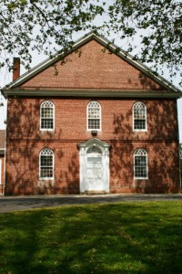
Cohansey Baptist Church

714 Roadstown Road
Bridgeton, NJ 08302
856 – 455 - 7787

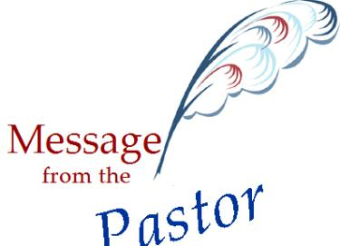

Greetings Saints! I trust that this message finds you well and in good spirits! It is amazing how fast time flies, as we are now embarking on the second month of 2013. This year so far has been good for me personally and for us collectively as a church. Just last Sunday, we were blessed to be able to welcome back Reverend David Laubuach who pastored Cohansey over thirty years ago. I am a firm believer that we must embrace the past, in order that it can inform our present, and prepare us for the future.
As I am writing this my heart is heavy because recently a friend of mine lost his ongoing battle with cancer. It was a reminder that this earthly life is fleeting at best and that we must do now what we may not be able to do tomorrow. As I have tried to reconcile this young loss of life in my mind, I am reminded by scripture that our goal in life, “…whether at home or absent, (is) to be pleasing to Him. “ (2 Corinthians 5:9b)
Therefore, my goal and our goal must always be to please God. That in itself may seem to be a daunting task but the reality is that on numerous occasions, God has already told us what we should do to please Him. We can begin by loving Him with everything that is inside of us and the outgrowth of this brand of love includes loving our neighbors and enemies. I wonder what would happen in our local church, our community, our state, and our nation if we truly sought to exercise the love of God. I am convinced that revival would break out and the question of, ‘what must I do to be saved’ would be on the lips of the masses. God has told us to show mercy and work towards justice. We must not remain silent if we are faced with injustice; instead, we must speak boldly and clearly about what our Christian faith informs us to believe. How can we please God? We can forgive liberally, encourage often, and exercise compassion in times of need. Simply put, we can “…be doers of the word, and not hearers only.” (James 1:22)
We must continually strive to put the scriptures into practice. Like anything else in life the more you use it, the better you get at it. As I think about my friend, I am reminded of the fragility of human life and therefore, in the days that I have left I must strive to be pleasing to God, will you join me?
I pray for you often and look forward to seeing you each week. May God bless you and keep you this day and always.

Your Brother in Christ,
Reverend Alexander G. Houston
Pastor
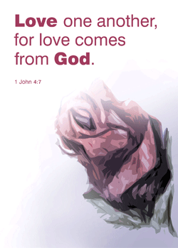

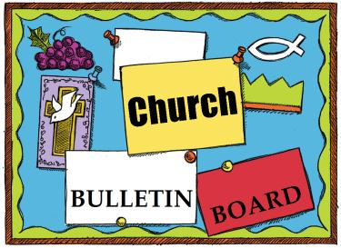

B.Y.F
Teen Retreat February 22 – 24 Grades 7 – 12
High Point Camp brings you the whole camp experience, from exciting activities to quality spiritual training in a Christ-centered environment. You will enjoy lots of singing, skits, new games, ping-pong, foosball, carpetball, basketball, tubing (weather permitting), and more. For more details contact Julie Fleetwood @ 455-3190.
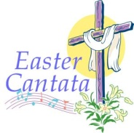
Saturday, February 9th from 9 AM – Noon will be an opportunity to work together in Christian fellowship as we beautify the parsonage. We will be scraping, painting, cleaning, etc. Please sign-up on the sheet in the narthex. See you there!
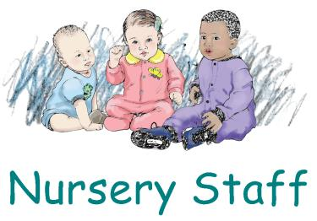
We are looking for one volunteer each week to assist our nursery staff. If you would like to help please see the sign-up sheet in the narthex. Feel free to sign up for a specific Sunday if you’d like. Thank you!

The Bereavement Committee is requesting volunteers to provide a covered dish for funerals held at Cohansey. If you would like to volunteer and provide a dish on needed occasions please sign up in the narthex. Thank You!
Remember the next newsletter articles, announcements, pictures, etc. are due, February 15, 2013. You can put them in the Newsletter mailbox, email them to me or call me. My email address is: nohowmom@comcast.net and my phone number is 856-455–2574. Thank you!

Thank you to all of those who faithfully give of their time and assemble the newsletter each month.

The choir is beginning rehearsals for our Easter cantata, “The Story – The Musical”, arranged and orchestrated by David Hamilton. The music was inspired by the book, “The Story.” Anyone interested in joining us for this Easter portion of “the grandest and most compelling story of all time” is welcome. Rehearsals start on February 11th at 8 PM in the sanctuary, preceded by regular choir rehearsal at 7 PM. There will be NO rehearsals on Monday, February 4, 2013.

(continued)

Aaron Silver would like to thank his church family for all the prayers and cards he received during his brief illness.
Dear Cohansey Baptist,
I would like to sincerely thank the Cohansey Baptist Prayer group, Workers for Christ Class, and all of our church family and friends for your prayers, cards, flowers and concerns while I was in the hospital and at home recovering from pneumonia. It meant so much and your thoughtfulness was deeply appreciated.
Sincerely, Sharon Thomas

Bridgeton Area Lenten Services
Theme: The Miracles of Christ
All Service Times @ 7:00 pm

Wednesday, February 13, 2013
Location: Berean Baptist Church
Speaker: Pastor Alexander G. Houston
Subject: Mark 5:25-34 “A Reach of Faith”
Special Music: Cohansey Baptist Church

Wednesday, February 20, 2013
Location: Cohansey Baptist Church
Speaker: Pastor Ken Scovell
Subject: Mark 5: 1-20 “Legion”
Special Music: Berean Baptist Church

Wednesday, February 27, 2013
Location: Pearl Street Baptist Church
Speaker: Pastor Aleksander Saar
Subject: John 11:20-44 “Raising of Lazarus”
Special Music: First Baptist Church

Wednesday, March 6, 2013
Location: Central Baptist Church
Speaker: Pastor Albert Morgan
Subject: Luke 17: 11-19 “Ten Lepers”
Special Music: Union Baptist Temple

Wednesday, March 13, 2013
Location: Union Baptist Temple
Speaker: Pastor Lou Spyes Jr.
Subject: John 9 “This I Know”
Special Music: Central Baptist Church

Wednesday, March 20, 2013
Location: First Baptist of Bridgeton
Speaker: Pastor David McCollum
Subject: Matthew 14: 22-33 “Walking on the Water”
Special Music: Pearl Street Baptist Church

Thursday, March 28, 2013
Location: Berean Baptist Church
Speaker: Pastor Jerry Fortunato
Subject: Luke 22:14-34 “Sitting with the Enemy”
Special Music: Pearl Street Baptist Church

The offerings collected throughout our Lenten Services will support two worthy causes: the ABCNJ Disaster Relief Fund and the Second Baptist Church of Atlantic City.

Lenten Hope
Lent is an occasion for us to journey with Christ … into tomorrow. For you never walk with Christ long but what the dawn breaks, the sun shines and hope breaks through.
—C. Neil Straight

1 Billy Williams, III

4 Ashleigh Elwell

5 David Ely

9 Kevin M.Stanfa, Sr.

10 Kim Mayhew

11 Joshua Bonham

12 Jeanette Bokma
13 Jim Johnson
Kim Johnson
Cindy Fithian

14 Kristine Halter
Frances Newkirk

15 Danny VanMeter

16 Ryan Hitchner

18 Bobbi Jo Hitchner
Megan Davis

19 Ava Houston

23 Kelly Hilbert

24 Nicole Gandy

26 Jeremy Dickinson

****If your name is not on our Birthday List or there needs to be a correction or your name has changed please let me know by calling 856-455-2574 or by email at nohowmom@comcast.net. Thank you****

Special dates

• African-American History Month
• Boy Scout Sunday, February 3, 2013
• Transfiguration of Our Lord, February 10, 2013
• Ash Wednesday, February 13, 2013
• Valentine’s Day, February 14, 2013
• First Sunday in Lent, February 17, 2013
• Presidents Day, February 18, 2013
• Second Sunday in Lent, February 24, 2013

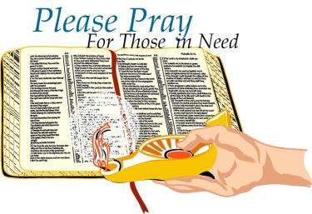

Please continue to pray for Linda Hill that blood counts are favorable for her to complete her treatments. Pray also for Ken and Matt.
Prayers of sympathy for the family of Karl Renne. Karl went home to be with Lord this past week. Especially keep Lenore in prayer.
Prayers of praise that John Carman’s tests were all negative for any cancer.
Congratulations to Patti Reeves on the birth of her grandson.
Prayers of praise for the fellowship we had with missionaries, Mark and Lera Hamilton.
Pray for Connie Ford’s niece, Emily Conhey, whose newborn passed away at birth.
Please Pray for healing and travel for Ed and Miriam Noyes, ABC missionaries to the Congo. Miriam had cancer related surgery. Pray for her recovery and treatment. Ed returned to the Congo on January 29th. Pray for safety.
Prayers of praise that Tom Laquitara’s cancer is now in remission. Praise God for healing.
Please keep Amy Silver’s niece, Penny Dunkelberger, in prayer as she continues to recover.
Prayers of praise that Sherry Willis’s brother-in-law, Dennis Gaggini, is now home and recuperating from bladder surgery.
Pray for David Cissioli who is the grandfather of Everett Levick’s son-in-law. David has heart problems and was hospitalized. He was released from the hospital and is now on hospice care. Please pray for David and the family as they travel this road together.
Shut-Ins:
Janet Bonaldo Ashley Guntow
Retirement Homes:
Ed Smith
Nursing Homes:
Don Brammer Anna Dickerson Arthur Levick Jeanette Merritt Alice Moore Ruth Levick
Battling Cancer:
Gloria Branca Emily Horton Erin Kennedy Giavana Krumaker Jonathan Lopez Debbie Marks Kale Jeff Mortimer Marion Nickopolous Jose` Nieto Louise Orsini Jerry Oswald Ed Peterson Cindy Frederick Ron Rouver Mike Scavelli Brenda Snyder Jayme Wright Debbie Johnson Mildred Gibe Paige Whitesell
Serious Condition: Dave Borrelli
In the Service:
Mike Dunkelberger Mark Elwell Ryan Fitian Andy Guth Kyle Mihalecz Nicky Mihalecz Brian Schier Doug Shimp Russell Shinn Shauna Sloan Jamili Andrew Tobin Lance Shestakoff

College Students:
Katelyn Bayzick Tyler Davenport Amaryllis DeJesus Ashleigh Elwell Sheli Loud David Johnson Sean Pedrick Ashley Shafer Jeremy Shafer Samantha Tobin Samuel Tobin Zack Tuthill Josh Weber Megan West Jen Maltese Ric Maltese

“I have called you by name,” says the Lord to each of us. “You are mine” (Isaiah 43:1). Thank you, God, for claiming and loving me. Amen.

What is the mission of American Baptist Home Mission Societies (ABHMS)?
ABHMS ministers as the caring heart, serving hands, going feet and prophetic voice of Jesus Christ—establishing ministries of discipleship, community and justice along with equipping and networking followers of Jesus to transform persons, congregations, neighborhoods and cultures throughout the United States and Puerto Rico.
What is the vision of ABHMS?
We seek to bring to bear the whole gospel on persons, congregations, communities and cultures, sharing God's love in word and deed in places and spaces where God's grace is not yet fully manifest. Our vision encompasses discipleship, community and justice.
What is the theme for the America for Christ (AFC) Offering 2013?
"Building Communities of Hope" Matthew 5:13-16
What is the financial goal for the AFC Offering 2013?
The financial goal for this year is $1,200,000.
What is the distribution of the total AFC Offering 2013?
The offering is distributed in three parts:
—29% supports regional ministries*
—59% supports the ministries of ABHMS (From the 59%, the Neighborhood Action Program receives 20%.)
—12% supports the offering's promotional and deputation costs
What Home Mission ministries are supported?
Developing Discipleship
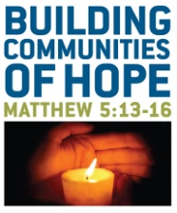
From Maine to Nebraska, 80—plus American Baptist churches participated in Missional Church Learning Experience groups, learning about becoming congregations that focus outside, rather than inside, the walls of their sanctuaries. The resulting outreach profoundly touched communities through dozens of programs, such as "Feed My Sheep," a free soup kitchen; "Building Bridges," which provides moving services, family Christmas baskets and community education about domestic violence issues in partnership with a local women's shelter;
ABHMS welcomed 12 new chaplains and pastoral counselors endorsed to share the life changing news of the Gospel with men and women in prisons, hospitals, counseling centers, chapels and churches throughout the United States and on foreign shores. More than 600 active chaplains and pastoral counselors ministered throughout the year, along with active and retired chaplains and pastoral counselors who served in more than 115 local churches throughout the United States.
More than 75 churches in more than seven regions and four academic settings participated in ABHMS "Got Style?" presentations about the strategy for congregational transformation, evangelism and holistic discipleship.
Building Community
ABHMS facilitated the placement of 732 volunteers across the United States and Puerto Rico.
Domestic development grants distributed by ABHMS totaled $150,000. In seven states, from Massachusetts to Wisconsin, these grants supported a youth summer jobs program; the expansion of an outreach program to teens, senior adults and unemployed; training 500 justice ministry workers in prisoner reentry projects; scholarships for a children's bereavement camp.
Twenty-four Neighborhood Action Program Christian center staff and board members gathered in Caguas, Puerto Rico, at an annual conference sponsored by ABHMS to share inspiration as well as practical insight about the community ministries they lead.
Pursuing Justice
ABHMS celebrated 65 years of ecumenical partnership with the Immigration and Refugee Program of Church World Service (CWS). More than 500,000 refugees have been settled by CWS' 37 communion partners since the program's inception; ABHMS alone has sponsored 105,000-plus. In 2011, ABHMS sponsored 2,084 refugees from 19 countries, including 657 from Cuba, 485 from Burma and 383 from Iraq. Also, ABHMS provided more than $60,000 to churches working with refugees.
An ABHMS/Cleveland Baptist Association prison ministry pilot project launched in 2010 resulted in C.O.T.A.A.N. (Covenant Outreach Through Advocacy and Agency Networking), a new ministry at Cleveland's Covenant Baptist Church that assists female returning citizens
ABHMS gathered with 30 other denominations in Connecticut at the Kaleidoscope Institute's Northeast region meeting and training event for diversity practitioners.

An Exciting Eulogy
Some men were talking about death and dying when this question came up: “What would you want people to say about you at your funeral?”
One replied, “I’d want people to say, ‘He was a great and compassionate humanitarian who cared about those in need.’”
A second said, “I’d want people to say, ‘He was a good father and husband, whose life was a fine example for others to follow.’”
A third answered, “I’d like them to say, ‘Look, he’s moving!’”

Blind Trust
Lex Gillette, a blind long-jumper from North Carolina, participated in the 2004, 2008 and 2012 Paralympic Games. Before an event, his guide shows him around the course. During competitions, the guide positions Gillette at the starting line, then goes to the sand pit, where he claps and calls steadily so the athlete can follow the sounds and run straight ahead. Gillette knows to jump when he hits his 16th
step.
Unable to see where he’s going, nor the line from which to jump, nor where he’ll land, Gillette entrusts himself fully to his guide. The result? Three consecutive silver medals, and a world record set in 2011.
We’re all blind to what lies ahead in life, so our guide, the Holy Spirit, goes before us and beckons us forward in the way we should go. Entrusting ourselves to God, we can do great things.

Mealtime as a Family
Amid busy and varied schedules, many families find a way to sit down together for dinner regularly. Family-health advocates describe the benefits: an increased sense of unity, children sharing news and feeling listened to, and the physical perks of a planned, seated meal.
In Scripture, many great encounters between people and God happen around meals. Abraham and Sarah prepare a meal for three guests who turn out to be angels (Genesis 18). God instructs the Hebrew slaves to eat a special meal together before their delivery from Egypt (Exodus 12); every year since, Jews have celebrated the Passover feast. Elijah is strengthened with food served by an angel (1 Kings 19). Jesus shares meals not only with religious leaders but with “sinners” (e.g., Matthew 9). Jesus’ Last Supper with his disciples before his death has become one of the church’s sacraments and a “foretaste” of the heavenly banquet to come.
When Christian families eat together, it’s a holy time in God’s presence, just as when the church shares Holy Communion — a true fellowship dinner!

Memory Verse:
These things I command you,
that you love one another.
~John 15:17
Jokes/Riddles:
Q: Why do fish live in salt water?
A: Because pepper makes them sneeze!
Q: Why did the computer squeak?
A: Because someone stepped on its mouse!
Q: Why do basketball players love donuts?
A: Because they dunk them!
Puzzle:

Bible Quiz:
Who were the craftsmen appointed by the Lord to design the Tent of Meeting and its furnishings while Israel was still in the wilderness before entering the Promised Land?
A. Moses and Joshua
B. Bezalel and Oholiab
C. Judah and Reuben
D. David and Jonathan
Answer: (See Exodus 31:1-11.)

SUNDAY | MONDAY | TUESDAY | WEDNESDAY | THURSDAY | FRIDAY | SATURDAY
“There is no remedy for love but to love more.”  —Henry David Thoreau  . |  |  |  |  | 1 | 2
3  Communion Sunday  9:30 AM Sunday School  10:30 AM Morning Worship  6-7:30 PM BYF - Here | 4  7 PM NO CHOIR | 5  9 AM Prayer Group | 6  10:30 AM – Manor  7 PM Bible Study | 7  7:30 – 8:30 PM Praise Band Rehearsal | 8 | 9  9 AM – Noon
10  9:30 AM Sunday School  10:30 AM Morning Worship  6 PM – 7:30 BYF | 11  6 PM Hand Chimes  7 PM Choir  8 PM Cantata | 12  9 AM Prayer Group  6:30 PM Trustees  7 PM Deacons  7 PM Missions Com  7 PM Music Comm. | 13  7 PM Lenten Service  @ Berean | 14  7:30 – 8:30 PM Praise Band Rehearsal | 15  Lamplighter Articles Due | 16
17  9:30 AM Sunday School  10:30 AM Morning Worship  6 PM -7:30 BYF | 18  6 PM Hand Chimes  7 PM Choir  8 PM Cantata  President’s Day | 19  9 AM Prayer Group  7 PM C.E. Board | 20  7 PM Lenten Service  @Cohansey | 21  7:30 – 8:30 PM  Praise Band Rehearsal  6:30 PM- White  Cross | 22  Sr. Youth Group  Winter Retreat | 23  Sr. Youth Group  Winter Retreat
24  9:30 AM Sunday School  10:30 AM Morning Worship  Sr. Youth Retreat | 25  6 PM Hand Chimes  7 PM Choir  8 PM Cantata | 26  9 AM Prayer Group | 27  7 PM Bible Study | 28  6:30 White Cross  7:30 – 8:30 PM Praise Band Rehearsal
“He has a right to criticize who has a heart to help.”
—Abraham Lincoln
2013 Church Meetings, Activities & Events

