The Lamplighter
JUNE 2014
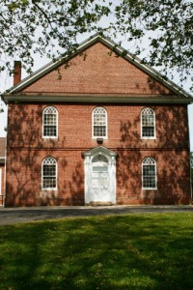
Cohansey Baptist Church

714 Roadstown Road
Bridgeton, NJ 08302
856 – 455 - 7787

Greetings to you in the name of our Lord and Savior Christ! I trust that this message finds you well and in great spirits. We have been mightily blessed God throughout the month of May here at Cohansey. God continues to add to our number and we are excited about what the future holds. As summer sets in, we look forward to the warm weather, beach time, and summer fun. However, let me encourage you to continue to come out to church this summer as we embark on a new summer sermon series, Psalms for the Summer. Each Sunday throughout the summer, I will be preaching from a different Psalm, you won’t want to miss it!

Summertime is a welcome sight after the long, difficult winter that we lived through this year. Therefore, I encourage you to take full advantage of the opportunities that the mild weather brings. If you are able get outside and go for a bike ride, work in your garden, or lay on the beach. Every opportunity that you have to be outside affords the priceless chance to take in more of God’s creation. The Psalmist wrote in Psalm 19:1, “...the heavens declare the glory of God; the skies proclaim the work of his hands.” As we take in the rising and setting of the sun, as we gaze at the stars and the moon in the sky, as we listen to the sounds of nature, and allow the breeze to blow on our faces, we experience the glory of God in new and profound ways. The Apostle Paul also provides us further insight when he writes in the epistle of Romans, “...for since the creation of the world God’s invisible qualities-his eternal power and divine nature-have been clearly seen, being understood from what has been made, so that men are without excuse.” We know God is because His creation is so amazing! Praise God! What a great reminder that every molecule that exists, every animal that scurries away as you approach, every bird that sings, fish that swims, even the existence of mosquitoes reminds us that God is God.

Get outside this summer and let me know how great you experienced God in that time. I trust that this message blesses you and I look forward to seeing you in church soon!

Your Brother in Christ,

Reverend Alexander G. Houston
Pastor

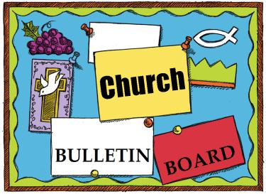

Remember the next newsletter articles, announcements; pictures, etc. are due, June 15, 2014. You can put them in the Newsletter mailbox, email them to me or call me. My email address is: nohowmom@comcast.net and my phone number is 856-455–2574. Thank you!
Thank you to all of those who faithfully give of their time and assemble the newsletter each month.

Looking for Volunteers
Cohansey Baptist is hosting VBS the week of June 23rd thru 27th, 2014.
This summer at VBS the children will be studying the 3 D’s Discover, Decide and Defend the truth about Jesus and who He really is. Don’t you want to be a part of helping children learn about Jesus in a really fun way? There are still ways for you to help out, MEN or women, food, guides, singing and just being an example of Christ. If you can’t be there all week that’s fine, just come and be a part of VBS. Please contact Andrea Levick if you can help.

325th Anniversary
In 2015 our church will be celebrating its 325th year of service to the Lord. We need to start planning for this event, if you would like to be a part of the planning process, please see Penny Timberman.

Volunteers Needed!
The families will be staying at Cohansey Baptist from; June 29th – July 7th.We are looking for those who are willing to help with set-up, drive the van morning and evenings, provide dinner and stay overnight. There is a sign-up sheet in the narthex or contact Emily Mayhew 451-4668 or Penny Timberman 451-4394. Please consider sharing your time and service.

If you or someone you know would like to sign-up for special music during the summer months, please see the sign-up sheet on the narthex bulletin board.
Answered Prayer
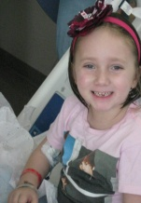
Praise God! Gia has been declared cancer free after 5 years of treatments, surgeries and extensive hospital stays. At the present time the tumor growth has stopped.

1 Edwin P. Fleetwood IV
Ryan Olbrich
Ed Guth Jr.
Karole King
2 Annette Cruzan
Terri West
Susan Willis
Nicole Campagna Bostwick
3 Joan Lentine
Cindy Marks
Brenda Williams
Leon Fithian
4 Danny Dilks
Stephanie Jones
Nancy Sloan
5 John Marks
6 Dennis Hitchner
Marvin Rammel
7 Gloria Levick

11 Margaret Bitters
15 Lauren Willis
Donald Sloan
17 Anna Bender
18 Nancy Gregory
19 Lee Shafer
George Thomas
20 Marion Clark
Mark Sloan
Marilyn Tharp
23 Jennifer Gandy
24 Kyle Ayars
Ryan Fithian
26 Roy Dunkelberger
Jodi Guth
27 Charlene Elbirn
28 April Guy
Tim Shafer
Cooper Levick
29 Helen Perry
30 Alyssa Cruzan
Dale Cruzan
June Marks
Doug VanMeter
Charley Levick

****If your name is not on our Birthday List or there needs to be a correction or your name has changed please let me know by calling 856-455-2574 or by email at nohowmom@comcast.net. Thank you****

Please keep these people in prayer as they deal with various physical problems. Pray for healing and complete recovery.
Irene Vetro R.C. Holt Evelyn Armstrong Bill Felmey Rose Gaggini George Moore Polly Davenport Donna Loud Gladys Guth Timothy Ross Harry Lodge Chris Blackburn, Jr.
Prayers of Praise:
Praises for June Pompper who was baptized on May 18th.
Keep those students who will be graduating from 8th grade, high school and college in prayer as they embark on a new adventure.
Please pray for the well-being of our country and our leaders. May God grant them wisdom as they deal with the situations around the world and here at home.
Congratulations to Michelle and Hoss Simpkins who welcomed a new baby boy into their family on May 14, 2014. His name is Sawyer Hudson Simpkins; he weighed 10 lbs. and is 19” long. Congratulations to the proud grandparents, Ed and Sharon Guth.
Shut-Ins: Janet Bonaldo Ashley Guntow Arthur Levick Ruth Levick Doris Newkirk
Retirement Homes:
Nursing Homes: Don Brammer Anna Dickerson Margaret McAllister
Battling Cancer: Gloria Branca Lisa Haffner Emily Horton Debbie Johnson Giavana Krumaker Jonathan Lopez Debbie Marks Lake Jeff Mortimer Marion Nickopolous Jose` Nieto Louise Orsini Ed Peterson Ron Rouver Mike Scavelli Brenda Snyder Paige Whitesell
Serious Condition: Dave Borrelli
In the Service: Mike Dunkelberger Ryan Fithian Kyle Mihalecz Nicky Mihalecz Brian Schrier Doug Shimp Russell Shinn Shauna Sloan Andrew Tobin Lance Shestakoff
College Students: Tyler Davenport Amaryllis DeJesus Katelin Elwell Steve Frantz David Johnson Mindy Williams Samuel Tobin Megan West
Peace for today
May today there be peace within.
May you trust God that you are exactly where you are meant to be.
May you not forget the infinite possibilities that are born of faith.
May you use those gifts that you have received, and pass on the love that has been given to you.
May you be confident knowing you are a child of God.
Let this presence settle into your bones, and allow your soul
the freedom to sing, dance, praise and love.
It is there for each and every one of us.
—St. Therese of Lisieux (1873-1897)

Recipe of the Month:
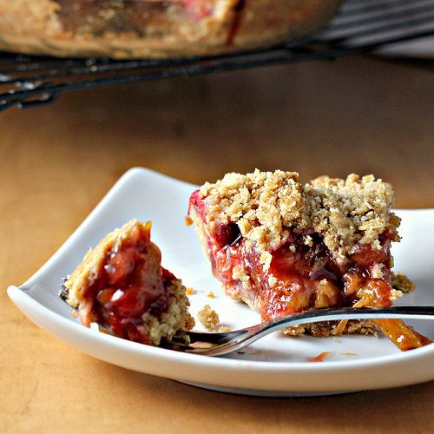
STRAWBERRY & RHUBARB CRUMB PIE Recipe courtesy of Magnolia Bakery
Yields one 9” pie

Pie Dough
1 cup flour
1/4 teaspoon salt
4 oz butter (1 stick), cold & cut into small pieces
2-3 tablespoons cold water
Filling
1 cup sugar
2 tablespoons all purpose flour
1 tsp orange zest (optional)
1/4 teaspoon salt
4 cups rhubarb, trimmed and cut into 1” & 1⁄2” pieces
3 cups strawberries, trimmed and cut in half (or quarters if they are large)
2 TBLS unsalted butter
Crumb
4 oz butter (one stick cold, unsalted & cubed)
1 1/3 cups flour
3/4 cup brown sugar
1/2 tsp ground cinnamon
3/4 teaspoon salt
Directions
Make your pie dough first. Preheat conventional oven to 425°. For pie dough, place the flour, butter, and salt into a food processor; pulse until the butter is pea sized and resembles a coarse meal. Add the water, one tablespoon at a time, and pulse until a crumbly dough forms. Turn the dough out onto a floured surface and flatten into a disc. Wrap and refrigerate the dough for approximately 30 minutes.
In the meantime, for the filling, combine the granulated sugar, flour, and salt in a large bowl. Remove 2 tablespoons and set aside.
To make crumb topping, place the butter, flour, brown sugar, cinnamon and salt into the food processor; pulse until the butter is mixed in and the texture is crumbly; set aside. (Or mix together in a bowl with a pastry cutter).
On a lightly floured work surface, roll the disk of dough into a circle shape, about 11” in diameter and 1/8” thick. Fit the dough over a 9-inch pie pan and crimp the edges as desired. Sprinkle the 2 tablespoons of the sugar/flour mixture that was set aside onto the bottom of the crust. Toss the rhubarb pieces in the remaining sugar mixture; set aside.
Pour the rhubarb filling evenly into the pie pan. Dot with 2 TBLS of butter. Cover the pie evenly with the crumb mixture. Place the pie on a sheet pan lined with parchment paper and put into the oven for 10 minutes. Reduce oven heat to 350° and bake for 35-45 minutes longer until the juices are thick and bubbly.
Carve Your Name on Hearts
A good character is the best tombstone. Those who loved you and were helped by you will remember you when the forget-me-nots are withered. Carve your name on hearts, and not on marble.
—Charles H. Spurgeon

Points for Honesty
A Sunday school teacher was telling his class the story of the Good Samaritan (Luke 10:25-37), in which Jesus describes three individuals’ responses to a man found beaten and in grave need of help along the side of the road. Hoping to bring home the point of the parable, the teacher asked the class, “If you saw a person lying on the roadside, all wounded and bleeding, what would you do?”
A hushed silence followed, broken after a moment by a thoughtful little girl: “I think I’d throw up.”

Memory Verse:

Hear ye children, the instruction of a father,
and attend to know understanding.
~Proverbs 4:1

Jokes:
Q: What do you call four bullfighters in quicksand?
A: Quattro sinko.
Q: What do you call a boomerang that doesn't work?
A: A stick.
Q: What is a ghost’s favorite position in soccer?
A: Ghoul keeper.
Puzzle”
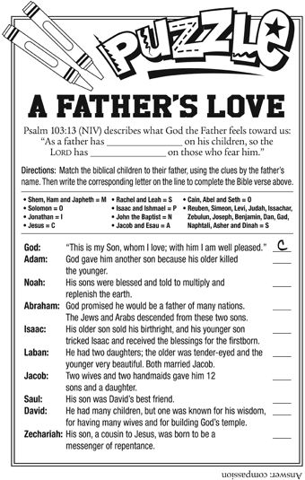

Bible quiz:
Which of the following is an accurate father-child match from Scripture?
A. Saul and David
B. Zechariah and Joseph
C. Abram and Ishmael
D. David and Boaz
Answer: (See Genesis 16:15.)

.

My Mission Field

From "Mother's Day" through "Father's Day" we will be collecting donations for our local pregnancy center, "Cornerstone Women's Resource Center". Baby bottle banks are available in the sanctuary. Take them home or to your workplace. All proceeds will benefit local babies. Checks can be made payable to Cornerstone WRC or Cohansey Baptist with a notation for Cornerstone. (We will need all banks returned.)
Together we can make a difference in the lives of mothers, fathers, not-yet-born babies and newborns. For more information on Cornerstone's ministry, including their
mobile ultrasound unit: http://www.cornerstonewrc.org
Tony Campolo's Next Chapter
On June 30th EAPE - The Evangelical Association for the Promotion of Education will legally shut down. Our new endeavor is THE CAMPOLO CENTER FOR MINISTRY based at Eastern University. This center will undergird the preaching and teaching ministries through which I will continue to challenge young men and women to commit themselves to full-time Christian vocations.

Thank you for your continued support of EAPE which enables us to fulfill obligations to this new ministry as well as our affiliated programs such as "The Simple Way". Located in a derelict Philadelphia neighborhood, we restore dilapidated houses and selling them to low-income families at cost with no down payment and long term mortgages with no interest. This is part of the mission not only to bring the good news of God's salvation to individuals, but also to bring people together to change this neighborhood into the kind of community that God wants it to be. In response one single mother said, "I'm so grateful that my God cares about what kind of house we live in!"
As I move into this new stage, I hope you will keep up with what I will be doing. You can do so by regularly checking the website http://tonycampolo.org/ where you will find a calendar of my speaking engagements. Also, the website will enable you to log on to the weekly podcasts of my radio program "Across the Pond".
Thank you for your continued support. Tony Campolo
BLANKET SUNDAY
What are the people who call the outside home using for shelter or warmth?
What are folks using for temporary shelter when tornadoes, earthquakes, etc strike?
What are the refugees in many parts of the world using for shelter or bedding?
And .... What am I doing for them?
There are many instances in our lives when we feel absolutely helpless, specifically concerning such monolithic issues as poverty and homelessness.
If we take the time to look there are very real solutions that can make a significant impact on the lives of these sisters and brothers in need.
Jesus told us, “’[For] I was hungry and you gave me food, I was thirsty and you gave me something to drink, I was a stranger and you welcomed me, I was naked and you gave me clothing, I was sick and you took care of me, I was in prison and you visited me. Truly I tell you, just as you did it to one of the least of these who are members of my family, you did it to me’ (Matthew 25:35-36, 40b, NRSV, emphasis added).”
Blankets matter because everyone matters. We are all part of the same human family and you can make a difference for those in need. By participating in Blanket Sunday YOU can make a real impact on the lives of those around you. (Envelopes are in the church pews or see any member of the Mission Board).

SUNDAY | MONDAY | TUESDAY | WEDNESDAY | THURSDAY | FRIDAY | SATURDAY
1  Communion Sunday  9:30 AM Sunday School  10:30 AM Morning Worship | 2 | 3 | 4  10:30 AM Manor Service  7:00 PM Bible Study | 5  7:30 PM  Praise Band Rehearsal | 6 | 7
8  9:30 AM Sunday School  10:30 AM Worship | 9 | 10  6:30 PM Trustees  7 PM Deacons  7 PM Missions Comm. | 11  7 PM Bible Study | 12 | 13 | 14
15  9:30 AM Sunday School  10:30 AM Worship | 16 | 17 | 18  7 PM Bible Study | 19 | 20 | 21
22  9:30 AM Sunday School  10:30 AM Morning Worship | 23 | 24  7 PM Brd. of Christian Ed.  7 PM Hospitality Mtg. | 25  7 PM Bible Study | 26 | 27 | 28
29  9:30 AM Sunday School  10:30 AM Morning Worship | 30 | “Don’t judge each day by the harvest you reap but by the seeds that you plant.”  —Robert Louis Stevenson |  |  |  | “A God wise enough to create me and the world I live in is wise enough to watch out for me.”  —Philip Yancey
JUNE 2014 Church Meetings, Activities & Events

