The Lamplighter

**SEPTEMBER 2013**

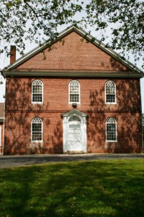**Cohansey Baptist Church**

**714 Roadstown Road**

**Bridgeton, NJ 08302**

**856 – 455 - 7787**

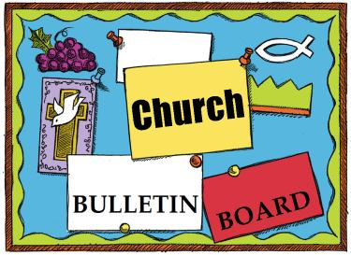



[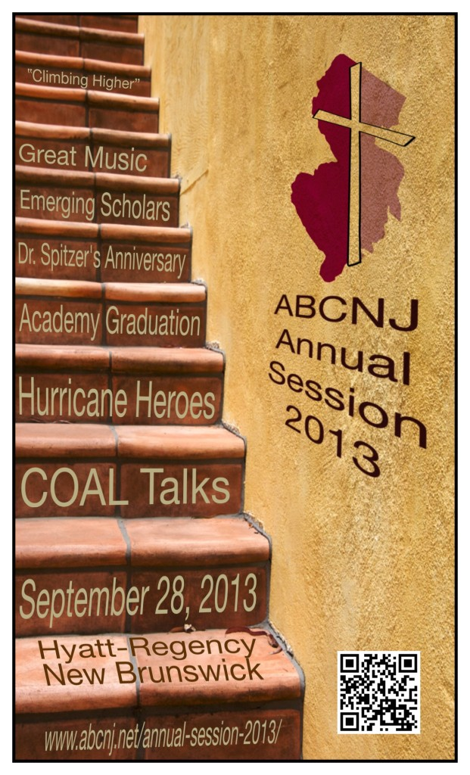](http://www.abcnj.net/wp-content/uploads/2013/06/Session-Flyer.jpeg)Remember the next newsletter articles, announcements; pictures, etc. are due**, September 15, 2013**. You can put them in the Newsletter mailbox, email them to me or call me. My email address is: [nohowmom@comcast.net](mailto:nohowmom@comcast.net) and my phone number is 856-455–2574. Thank you!

Thank you to all of those who faithfully give of their time and assemble the newsletter each month.

The choir has begun rehearsals. We have nice new songs as well as some oldies but goodies. There will be no rehearsal on Labor Day, but we will resume on Monday, September 8, 2013. Also note that the choir will be singing on Sunday evening September 8th at the Wesleyan Church on Old Deerfield Pike at 6 PM. bring a friend and enjoy a night of singing.

The Music Committee will meet on Tuesday, September 3, 2013 at 7 PM in the chapel.

**ABOUTFACE T-shirts** are in. If you would still like to place an order, we have plenty of extras!

SM, M, LG, XL - $15

2X, 3X - $20

Please see Ken Perry

**Don’t Forget** to join us on Sunday morning **September 8th at 9:30 AM** for our **Sunday School Open House in the Fellowship Hall.** Stop by and meet our teachers, check out our curriculum amd receive information about our children and adult Sunday school programs. From 9:30 AM to 9:55 AM will be the Open House and refreshments. From 9:55 AM to 10:15 AM we will break into classes. Sunday schoolis a great place to discover God’s Word and build lasting relationships with your fellow brothers and sisters in Christ! Hope to see you there!

ABCNJ 43rd Annual Session

September 28, 2013

At the Hyatt Regency-New Brunswick

This year marks the 183rd meeting of the American Baptist Churches of New Jersey. We invite our ABCNJ community to explore ministry opportunities and celebrate the progress we have made in serving Christ over this past year.

Please contact the church office if you would like to attend.

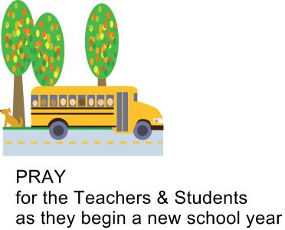



3rd – Carroll Bickley

Bernard DeVol

David Seay

4th – Anthony Maltese

Bradley Silver

5th - Alan Gregory

Billy Halter

Ken Hill

7th - Irving Gandy, III

Logan Willis

8th - Howard Willis, Sr.

10th – Patti Lister

11th - Irving Gandy, IV

12th- Emily Grindle

14th – Natasha Wagner

16th – Dale Cruzan, III

Lindsey Fithian

19th – Charlotte Higgenbothem

Margaret Kates

Howard Willis, Jr.

20th – Ella Marino

21st - Jessica Shimp

22nd- Garry Timberman

25th - Terri Hitchner

28th - Bucky Tharp

29th - Joyce Wagner

Ellen Davis

30th - Sallie Counselor

*\*\*\*\*If your name is not on our Birthday List or there needs to be a correction or your name has changed please let me know by calling 856-455-2574 or by email at* [*nohowmom@comcast.net*](mailto:nohowmom@comcast.net)*. Thank you\*\*\*\**

|  |
| --- |
|  |
|  |



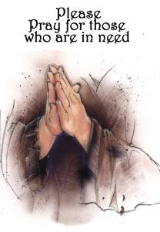

|  |
| --- |
|  |

|  |
| --- |
|  |

**Please keep these people in prayer as they deal with various physical problems. Pray for healing and complete recovery.**

June Marks Doris Newkirk Don Stanson Irene Vetro Bud Newkirk Gale Owens Mary Houston Gordon Houston Nola Willis Carol Hunt Patti Reeves Steve Ernest Desha Carson, Matt and Family John Carman Heath Willis Peggy Bitters Howard Willis, Sr.

**Please pray for those who have recently lost loved ones:** The Family of Mildred Gibe The Family of Lee Hitchner

**Please pray for the well-being of our country.**

**Shut-Ins:** Janet Bonaldo Ashley Guntow Arthur Levick

**Retirement Homes:** Ed Smith

**Nursing Homes:** Don Brammer Anna Dickerson Ruth Levick Jeanette Merritt Margaret McAllister Alice Moore

**Battling Cancer:**  Jayme Bickings Gloria Branca Cindy Frederick Lisa Haffner Emily Horton Debbie Johnson Giavana Krumaker Tom Laquitara Jonathan Lopez Debbie Marks Kale Jeff Mortimer Marion Nickopolous Jose` Nieto Louise Orsini Jerry Oswald Ed Peterson Ron Rouver Mike Scavelli Brenda Snyder Paige Whitesell Jayme Wright

**Serious Condition:** Dave Borrelli

**In the Service:** Mike Dunkelberger Ryan Fithian Andy Guth Kyle Mihalecz Nicky Mihalecz Brian Schrier Doug Shimp Russell Shinn Shauna Sloan Jamili Andrew Tobin Lance Shestakoff

**College Students:** Katelyn Bayzick Tyler Davenport Amaryllis DeJesus Ashleigh Elwell Sheli Loud David Johnson Sean Pedrick Ashley Shafer Jeremy Shafer Samantha Tobin Samuel Tobin Zack Tuthill Josh Weber Megan West

|  |
| --- |
|  |

**Join us for our FREE**

2-Day concert event weekend!

**Sept 14th: 1pm – 10pm**

**Sept. 15th: 9am – 12 noon**

For more info & schedule of events visit us on the web at: cohanseybaptist.com/**ABOUTFACE Please keep this weekend in prayer that souls may be won for Christ.**



**Recipe of the Month:**

[](http://www.luicucina.com/2013/08/apple-cinnamon-white-cake.html)A buttery white cake that comes together in minutes but tastes like you spent all day making it. Adding apples and cinnamon with brown sugar in layers makes this cake into an autumn delight. A scoop of ice cream is especially good with this cake.

**Apple Cinnamon White Cake**  
*makes 1 9x5-inch loaf*  
Ingredients:

* 1/3 cup brown sugar
* 1 teaspoon ground cinnamon
* 2/3 cup white sugar
* 1/2 cup butter, softened
* 2 eggs
* 1 1/2 teaspoons [vanilla extract](http://www.amazon.com/gp/product/B005MIWPGC/ref=as_li_qf_sp_asin_il_tl?ie=UTF8&camp=1789&creative=9325&creativeASIN=B005MIWPGC&linkCode=as2&tag=flsctv-20)
* 1 1/2 cups all-purpose flour
* 1 3/4 teaspoons baking powder
* 1/2 cup milk
* 1 apple, peeled and chopped

Instructions:

1. Preheat oven to 350 degrees F (175 degrees C). Grease and flour a 9x5-inch loaf pan.
2. Mix brown sugar and cinnamon together in a bowl.
3. Beat white sugar and butter together in a bowl using an electric mixer until smooth and creamy. Beat in eggs, 1 at a time, until incorporated; add vanilla extract.
4. Combine flour and baking powder together in a bowl; stir into creamed butter mixture. Mix milk into batter until smooth. Pour half the batter into the prepared loaf pan; add half the apples and half the brown sugar mixture. Lightly pat apple mixture into batter. Pour the remaining batter over apple layer; top with remaining apples and brown sugar mixture. Lightly pat apples into batter; swirl brown sugar mixture through apples using a finger or spoon.
5. Bake in the preheated oven until a toothpick inserted in the center of the loaf comes out clean, 30 to 40 minutes.

|  |
| --- |
| **Every One Counts!** |
| I’m an avid player of Yahtzee, in which you roll five dice to collect different number combinations. It’s a game of both chance and strategy. Because it seems less problematic to accept a roll that’s short by one point rather than a roll that’s short by, say, six, every so often I’m disappointed to discover I’ve missed winning by only one point.   We do something similar in church and other parts of life: dismiss a child’s idea as less important than an adult’s; worry more about pleasing the “big givers” at church than the ones who contribute less; check in on the longtime member who misses worship once but forget about the newcomer who attended twice, then didn’t return.   Jesus, the Good Shepherd, leaves 99 sheep in order to go after just one who is lost. May we learn from his example that everyone — every *one* — counts.   —Heidi Mann |

|  |
| --- |
| **The Labor to Which We're Called** |
| In words attributed to Mother Teresa, “Many people mistake our work for our vocation. Our vocation is the love of Jesus.” As we celebrate Labor Day, what does such a distinction mean?   *Vocation* comes from Latin for “calling.” Christians understand vocation as that for which God created you, involving activities you do well, enjoy and feel good about doing, and that serve others. If you’re blessed to earn a paycheck doing something that fits those categories, then your profession or occupation — your work —likely is your vocation.   Other people work a paying job because an opportunity presents itself and the income is needed, even if it isn’t their favorite thing to do. Perhaps they live out their truest vocation during non-employment hours: singing with a choir, raising children, building houses with Habitat for Humanity.   Christians in any capacity, paid or not, can live out Jesus’ calling to love God and neighbor with our whole being (Luke 10:27). When God is “CEO” of our lives, it shows in how we treat our fellow laborers. |
|  |

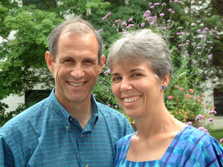

**

|  |
| --- |
|  |

Family Promise of Cumberland County is a network of area congregations housing local families who are experiencing temporary housing difficulties. It is our goal to provide safe, hospitable environments while they work to get back on their feet. Twenty-three congregations have pledged to support and/or host families. We are one of the hosting churches.

Salem County Family Promise has been taking some Cumberland County families while we are still raising funds for our Day Center and Director’s salary. We would like to help fill their congregation rotation by supplying host facilities and support. They have asked us to host families over the Thanksgiving and/or Christmas weeks. This would be a great time to take part in the Family Promise experience.

To accomplish our mission, we will need sheets, blankets, and pillowcases for twin sized beds. We also need volunteers to cook dinners, to set up classrooms as guest bedrooms, and to spend time with our guests. There are many jobs for all ages. See Penny Timberman and Emily Mayhew for more information.

Find out more about Family Promise at ABOUTFACE on September 14-15.

Meet OUR missionaries: Ed & Miriam Noyes

Ed and Miriam Noyes serve in the Democratic Republic of Congo. Ed supports and advises Congolese Baptists working for more productive, profitable and sustainable agricultural practices among semi-subsistence farmers. He strengthens the skills of Christians to research and innovate, to teach, and to promote best practices in agriculture so that the Church becomes a real force contributing to food security and expanding opportunities for Congolese living on the margins. Miriam had successful cancer surgery in January - PRAISE GOD - and returned to Africa in May.  She works with illiterate women, writing for and supervising church-based literacy programs, advises Baptist Pygmy evangelism efforts, and helps develop and print training materials for rural pastors and lay leaders.  Please pray that God will continue to bless their ministry to the Congolese.



**Memory Verse:**

**Study to show yourself approved unto God.**  
  
**~II Timothy 2:15a**

**Jokes:**

Q: How do we know that cars are in the New Testament?  
A: Because Jesus was a car painter!  
  
Q: Where do you find rain gear in the Bible?  
A: On the book of Goloshes. (Colossians).   
  
Q: How do you study the Bible?  
A: You Luke into it.

**Puzzles:**

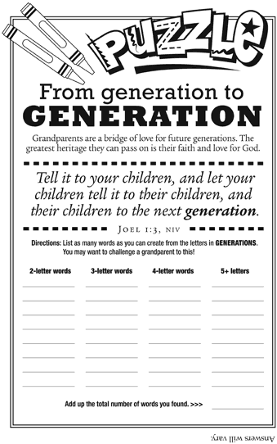

**Bible quiz:**

Elisha was appointed by this prophet to be his successor. Elisha then watched as this man was taken up to heaven in a fiery chariot. Who was the prophet?   
  
A. Amos   
B. Elijah   
C. Isaiah   
D. Ezekiel   
  
Answer: (See 2 Kings 2:11.)



God that He is with us in whatever we may be going through. Although I wish summer could last forever, the fall here and I welcome the inherent change that comes with it.

I pray that this blesses you and I look forward to seeing you in church soon Greetings in the name of our Lord and Savior Jesus Christ! I trust that this message finds you well and in good spirits! Things are going great at the Cohansey Baptist Church and we are thankful to God for sustaining us throughout these many years. On the last Sunday in August three people were baptized, praise God! The church was nearly full as we witnessed a sacred ordinance of the church. Additionally, we are looking forward with great anticipation to ABOUTFACE 2013, on September 14-15th, I hope that you will come out and be a part of this life changing event.

As we sit on the cusp of a new month and the final quarter of 2013, I encourage you to be intentional in observing the change of seasons. I want to see the changes, the differences, and uniqueness of each season as it leaves and a new one arrives. Sometimes in the business of life we fail to recognize the beauty that is right in front of us. However, we must resolve to welcome the changes as they come. The Bible provides insight on the seasons of life:

*“There is time for everything, and a season for every activity under the heaven: a time to be born and a time to die, a time to plant and a time to uproot, a time to kill and a time to heal, a time to tear down and a time to build, a time to weep and a time to laugh, a time to mourn and a time to dance, a time to scatter stones and a time to gather them, a time to embrace and a time to refrain, a time to search and a time to give up, a time to keep and a time to throw* *away, a time to tear and a time to mend, a time to be silent and a time to speak, a time to love and a time to hate, a time for war and a time for peace.” Ecclesiastes 3:1-8 NIV*

As seasons change in the world and in our lives, we must not buck the change but embrace what is taking place. More importantly, we must pray to ask for guidance about how we should approach the season that we are currently in. Regardless of what is happening or the changes that we are experiencing, we have an assurance from.

In His Service, Rev. Alexander G. Houston, Pastor



|  |
| --- |
| **Special Dates** |
| • Labor Day, *September 2, 2013*  • National Grandparents Day, *September 8, 2013*  • Patriot Day, *September 11, 2013*  • Hispanic Heritage Month, *September 15-October 15, 2013*  • First Day of Autumn, *September 22, 2013* |

|  |  |  |  |  |  |  |
| --- | --- | --- | --- | --- | --- | --- |
| **SUNDAY** | **MONDAY** | **TUESDAY** | **WEDNESDAY** | **THURSDAY** | **FRIDAY** | **SATURDAY** |
| 1 ***Communion Sunday***  9:30 AM Sunday School  10:30 AM Morning Worship | 2  NO CHOIR  Labor Day | 3  9 AM Prayer Group  7 PM Music Committee | 4  10:30 AM Manor Service  7 PM Bible Study | 5  7:30 – 8:30 PM  Praise Band Rehearsal | 6 | http://www.captioneditor.newsletternewsletter.com/CaptionEditor/ProcessedImages/apples_9610c2_web.jpg?guid=0d8c8e07-6c1b-4425-9b66-359af7f539347 |
| 8  9:30 AM ***Sunday school open House***  10;30 Morning worship  6 PM Hymn Sing @ Wesleyan Church  Grandparents Day | 9  7 PM Choir | 10  9 AM Prayer Group  6:30 PM Trustees  7 PM Deacons  7 PM Missions | 11  7 PM Bible Study | 12  7:30 – 8:30 PM  Praise Band Rehearsal | 13  http://www.captioneditor.newsletternewsletter.com/CaptionEditor/ProcessedImages/thanks_8970c5_web.jpg?guid=47f39cfc-07e9-4b62-8a01-0d34ae25f41a | 14  **1:00 – 10:PM** **ABOUTFACE** |
| 15  **9 AM – 12 N**  **ABOUTFACE**  **6 PM BYF Kick-off *Lamplighter Articles***  ***Due*** | 16  7 PM Choir | 17  9 AM Prayer Group  7 PM C.E. Board | 18  7 PM Bible Study | 19  7:30 – 8:30 PM  Praise Band  http://www.captioneditor.newsletternewsletter.com/CaptionEditor/ProcessedImages/fall_9686c1_web.jpg?guid=7e39a0ae-97a4-4bfa-97e3-d3bb0368fbad | 20 | 21  *“Education is learning what you didn’t even know you didn’t know.”  —Daniel J. Boorstin* |
| 22  9:30 AM Sunday School  10:30 AM Morning Worship  Autumn Begins | 23  7 PM Choir | 24  9 AM Prayer Group | 25  7 PM Bible Study  http://www.captioneditor.newsletternewsletter.com/CaptionEditor/ProcessedImages/autumn_5971c3_web.jpg?guid=9e1a9dfc-ad65-41d2-bcfa-a06d9c9ebc93 | 26  6:30 PM- White  Cross  7:30 – 8:30 PM  Praise Band | 27 | 28 |
| 29  9:30 AM Sunday School  10:30 AM Morning Worship | 30  7 PM Choir | http://www.captioneditor.newsletternewsletter.com/CaptionEditor/ProcessedImages/apples_9611c1_web.jpg?guid=131a0a27-e098-4cda-9d2a-0db09b976962 |  | *As summer changes to fall, God’s love remains constant. Therefore enter into the presence of the Lord of all seasons.* |  |  |
|  |  |  |  |  |  |  |



**2013 Church Meetings, Activities & Events**