The Lamplighter
OCTOBER 2014
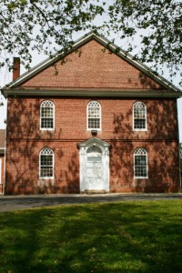
Cohansey Baptist Church

714 Roadstown Road
Bridgeton, NJ 08302
856 – 455 - 7787

Greetings, in the name of our Lord and Savior Jesus Christ and I trust that this message finds you well and in good spirits. The year is steadily moving along and we are welcoming the month of October and the brisk weather and autumn beauty that it brings. September was a busy and blessed time at the Cohansey Baptist Church as we continued to serve the Lord together. On Friday, September 19th, we received a wonderful visit from one of the missionary families whom we support, Carlos and Marya Bonilla Giovanetti, along with their daughters. This family lives and engages in ministry while being stationed in Nicaragua. During our time together the “BG’s” shared their inspirational stories of ministry overseas and the blessings and obstacles that they encounter. The Mission Board did a wonderful job, putting the program together and we had a great evening of food, fellowship, and fun.

After hearing the powerful testimonies of the “BG’s” the urge to become an international missionary could be great. In the gospel according to Mark, we read the following words, “And He said to them, “Go into the entire world and preach the gospel to all creation.” Jesus was sharing with the disciples His desire for them to go everywhere and share the good news of salvation. The world is such a large place and there are so many areas that need to hear the good news of Jesus Christ, the question is, where do we begin?
If you are unable to leave all that you have and embark upon an international missionary journey, allow me to encourage you to start wherever you are. The world does not simply encompass countries but also small towns, tight knit communities, and major metropolises. Share the gospel with your friends and family members in a way in which they can receive. Pray to God for direction in where you should share and with whom should you share. Make a commitment that you do not simply want to be a church member; rather, you want to exemplify being a disciple of Christ. I challenge all of us to be “missionaries” in our homes, schools, churches, and communities and witness the power of God.

I trust that this message blesses you and I look forward to seeing you in church soon. If I can ever be of any service, please do not hesitate to contact the church office.

In Brotherly Love,
Reverend Alexander G. Houston
Pastor

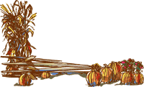

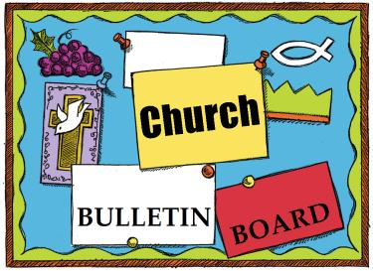
Remember the next newsletter articles, announcements; pictures, etc. are due, October 15, 2014. You can put them in the Newsletter mailbox, email them to me or call me. My email address is: nohowmom@comcast.net and my phone number is 856-455–2574. Thank you!
Thank you to all of those who faithfully give of their time and assemble the newsletter each month.

325th Anniversary
In 2015 our church will be celebrating its 325th year of service to the Lord. We need to start planning for this event, if you would like to be a part of the planning process, please see Penny Timberman.
Family Promise has a lot going on to get the doors open for the new Center:
- We have a Quarterly Fun-raiser. Keep filling up the quarter rolls found in your pews.

- The carpentry work is completed on the center and our church is cleaning, fixing up, and supplying the one and a half bathrooms to get them ready. (items needed are; cleaning supplies, childproof locks, rubber mat, toilet paper, paper towels, hand soap, paper cups & dispensers, bath linens for 14 people, towel bars, bath mat, first aid kit, trash baskets, plunger, & bowl brushes)

- Bethany Grace Community Church is renting to Cumberland County Family Promise space in their office building which is located at 31 N. Pearl Street in Bridgeton. This is the new Center for Family Promise where the families will be housed during the day, also it will be the family’s home address, where the children will be picked up for school and where the Director is located to work with the families.

But whoever has the world’s goods, and sees his brother in need and closes his heart against him, how does the love of God abide in him?
I John 3:17

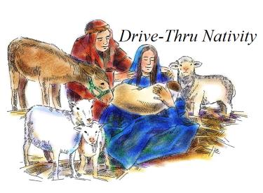
The Hospitality Committee is in need of your HELP!

Saturday, December 6, 2014 6-9PM the Cohansey Baptist Church will hold its first annual DRIVE THRU LIVE NATIVITY

If you would like to volunteer your time to prepare for this joyous event, serve as actors that night or just learn more, please see one of the Hospitality Committee Members:
Brenda Tobin, Emily Mayhew, Linda Turner, Diane Crispin, Sherian Cecchini, Amy Silver, or Penny Timberman

Church Activities and Events (continued)

USED CLOTHING COLLECTION ON

OCTOBER 25, 2014

Cohansey Baptist will be raising money for AboutFace and our Anniversary Celebration. We receive money for every pound we collect. Drop off now until October 23rd at the church.

Items we are collecting:

- Wearable & Usable Clothing
- Shoes, Belts, Handbags
- Linens
- Stuffed Animals
- Hard Toys

(Please put all items that you are donating into tightly tied plastic bags.)

For any questions contact, Mark Willis, Ed & Sharon Guth

JOIN US ON OCTOBER 12TH AS WE CELEBRATE PASTOR HOUSTON ON PASTOR APPRECIATION SUNDAY.
We invite everyone to bring a cover dish for the luncheon after church in the Fellowship Hall.
Come and show your appreciation for Pastor Houston and his family by joining us.

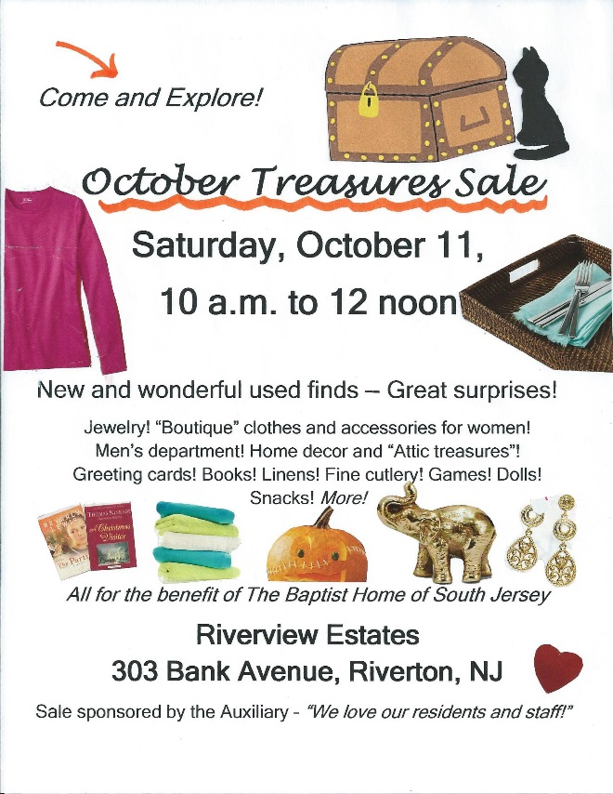

The Overland White Cross Gift Board is "sold out" with all the item tags taken. The items purchased are going to Baptist Children's Services YES! (Youth Empowered to Succeed) in the Philadelphia area. This ministry is dedicated to provide quality residential care and educational support to youth with a goal of reuniting them with their families or assisting in an alternative planned permanent living arrangement. If you have taken a gift tag, but have not yet brought in your item ... there is still time to do so. Please drop it off in the basket at the front of the church or see Diane Smith. If you didn't select a gift tag to purchase a needed item, but still want to give in some way to this ministry, you can give a Wal-Mart, Kmart or Visa/MC gift card.

- Ben Turner, Jr.

- Lucretia Olbrich

- Kimberly Nehra

7 Kayla VanMeter

8 Jon Newkirk
Brian Sebastian

9 Jim Ewing

10 Tiffany Sloan
Courtney Sloan

11 Daniel Bitters

13 Bob Riggins, Sr.

15 Brian Dunkelberger
Donna Stanfa

17 Julie Fleetwood
Gary McAllister, Sr.
Bob Riggins, Jr.

18 Stacey Smick
Chris Levick

19 Christianna Johnson

20 Carol Thomas

21 David Bostwick, Sr.
Arminda Williams
Brittany Sloan

22 Nancy Baker
Jacob Gregory

23 Mark Levick

25 Evered Levick, Jr.
Leeann Perry
Samantha Seay

26 Dennis Bitters
Becky Maltese

27 Staci Willis

28 Alice Dunkelberger
Mark Willis

30 Charles Ayars, Jr.
Maxwell Dilks
Chris Holt

****If your name is not on our Birthday List or there needs to be a correction or your name has changed please let me know by calling 856-455-2574 or by email at nohowmom@comcast.net. Thank you****

Special Dates

• World Communion Sunday, October 5, 2014
• Columbus Day Observance, October 13, 2014
• Reformation Sunday, October 26, 2014
• Reformation Day, October 31, 2014

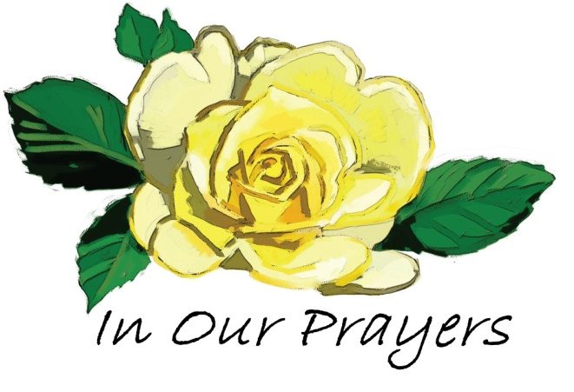

Please keep these people in prayer That God may manifest His healing in them and He will be praised.

Irene Vetro R.C. Holt Bill Felmey Rose Gaggini George Moore Gladys Guth Timothy Ross Carol Shimp Baby Alice Uhland
Prayers of sympathy for the families who have loved ones who have gone home to glory:
Mary Hemple and the Sickler Family; the Lucas Family; and the Levick Family
Please pray for the well-being of our country and our leaders. May God grant them wisdom as they deal with the situations around the world and here at home.
Shut-Ins: Janet Bonaldo Ashley Guntow Ruth Levick Doris Newkirk
Nursing Homes: Anna Dickerson Margaret McAllister
Battling Cancer: Gloria Branca Lisa Haffner Emily Horton Debbie Marks Lake Jeff Mortimer Marion Nickopolous Louise Orsini Ed Peterson Ron Rouver Mike Scavelli Brenda Snyder Aaron Silver, Jr.
Serious Condition: Dave Borrelli
In the Service: Mike Dunkelberger Kyle Mihalecz Nicky Mihalecz Brian Schrier Doug Shimp Russell Shinn Shauna Sloan Andrew Tobin Lance Shestakoff Jay Perticari
College Students: Tyler Davenport Amaryllis DeJesus Katelin Elwell Steve Frantz David Johnson Mindy Williams Samuel Tobin Megan West Melissa Smith Megan Smith

The Quiet Hour
Speak, Lord, in the stillness, while I wait on Thee;
hushed my heart to listen, in expectancy.
Speak, O blessed Master, in this quiet hour,
let me see Thy face, Lord, feel Thy touch of power.
For the words Thou speakest, “They are life” indeed;
living Bread from heaven, Now my spirit feed!
All to Thee is yielded, I am not my own;
blissful, glad surrender, I am Thine alone.
Fill me with the knowledge, of Thy glorious will;
all Thine own good pleasure, in my life fulfill.
Like a watered garden, full of fragrance rare,
ling’ring in Thy presence, let my life appear.
—Emily M. Crawford

Recipe of the Month:
Crock Pot Apple Crisp

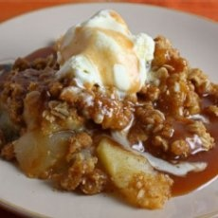
Ingredients:
- 8 apples, peeled. cored and sliced thinly
- 1/2-1 teaspoon cinnamon
- 1/4 cup white sugar
- 3/4 cup flour
- 3/4 cup oatmeal
- 3/4 cup brown sugar
- 1/2 cup butter

Directions:
Generously spray a crock pot with non-stick cooking spray, line with apples. Sprinkle the white sugar and cinnamon over top.
Mix together flour, brown sugar, and oatmeal. Cut in butter with a pastry blender until you get pea size pieces of butter in a bowl.
Cover the apples with this mixture.
Pack the flour-oatmeal-brown sugar-butter mixture. Cook on high for 3 hours.
Use a medium size crock pot to make this. Using a large crock pot will probably not work well as the ingredients will be too spread out and may burn around the edges.
Serve with vanilla ice cream

What's a Christian to do with Halloween?

These days, children associate Halloween with trick-or-treating and candy. But centuries ago, Christians named the night before All Hallows’ Day (All Saints’ Day) “All Hallows’ Eve.” As the faithful prepared to remember people who were entrusted to resurrection life, they adopted various traditions to poke fun at death.
Around the world, Christians observe Halloween differently: In Poland, kids pray aloud while walking through forests to comfort souls of the dead. In Spain, tolling church bells remind people to remember the saints. In Finland, so many people light candles in cemeteries that the observance is called “seas of light.” Although some Christians steer clear of Halloween, others use it as an evangelism opportunity and provide entertainment alternatives such as harvest parties.
No matter your views, you can remind children that though it’s fun to pretend, we can always be ourselves with God. Whatever our features and flaws, we need not and cannot hide from God behind masks. God made us in his holy image and loves us as his holy — hallowed! — children.

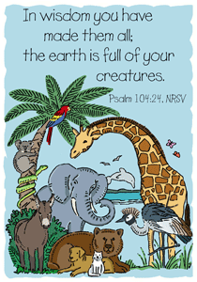
Memory Verse:

Jokes:
Q: What do you call a single vampire?
A: A bat-chelor.
Q: Why didn't the skeleton cross the road?
A: He didn't have the guts!
Q: Why are graveyards noisy?
A: Because of all the coffin!

Puzzle:
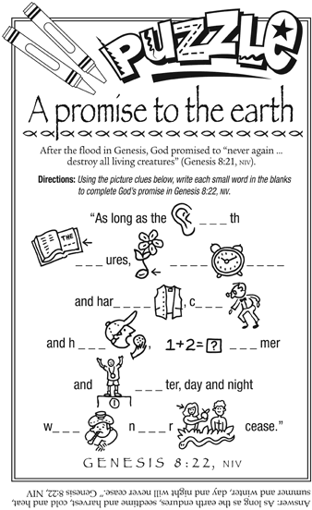

Bible quiz:
What modern expression comes from the practice, described in Leviticus, of a priest confessing Israel’s sins over the head of an animal and sending it (and the sins with it) into the desert?
A. hogwash
B. from the horse’s mouth
C. monkey business
D. scapegoat
Answer: (See Leviticus 16:10, 21, NIV.)

SAVE THE DATE: SEPTEMBER 19

We will have an evening of fellowship and food when "The BG's" visit Cohansey Baptist on September 19th from 6:00 pm until 8:30 pm.
Missionary Family Visit at Cohansey Baptist
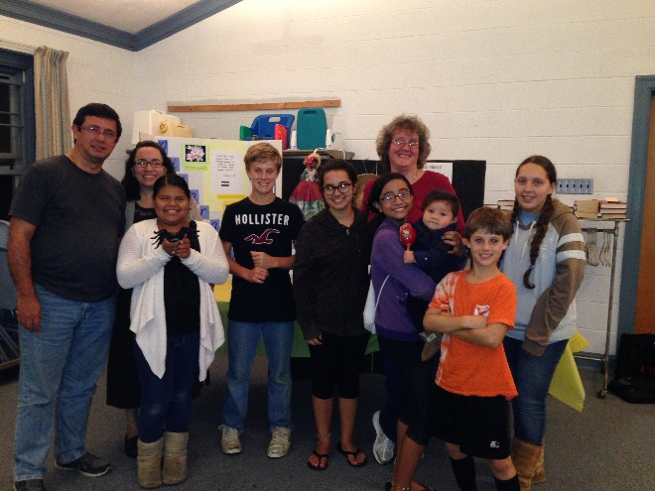
On Friday evening, September 19, we were blessed to have a wonderful evening of fellowship and food with "The BGs" - the Bonilla-Giovanetti Family - Carlos & Mayra (left) and daughters, Carolina (center) and Daniela (holding baby).
They are in the US visiting their supporting churches after attending the International Missions Conference celebrating 200 years of Baptist witness to the world. Missing was their son, Alberto, who is a freshman at Eastern University in Biblical Studies and History.
We learned all about their current ministry in Nicaragua as well as their previous service in Spain and Chile. It was also very interesting to hear about the customs, foods, history, demographics, and geography of the region. As Carlos and Mayra pointed out, Nicaragua is "a land of many contrasts".

A freewill offering was taken for the family for use in their ministry. If you would like to contribute please see a member of the Missions Board and we will forward your gift. You can also learn more about "the BGs" (and/or give financial support) at http://www.internationalministries.org/teams/50-bonilla-giovanetti
or follow them on FaceBook at https://www.facebook.com/BGsEnRoute.

Thank you again Carlos, Mayra, Carolina and Daniela for visiting with us and reminding us to "Rejoice with them that do rejoice, and weep with them that weep." (Romans 12:15) Your faithfulness to God's calling in your lives is a witness to many.

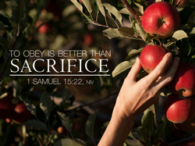

SUNDAY | MONDAY | TUESDAY | WEDNESDAY | THURSDAY | FRIDAY | SATURDAY
At the beginning of another week, we pause to remember that God is above all and in all. Thank you, God, for all life brings! | 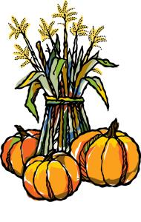 |  | 1  10:30 AM Manor Service  7:00 PM Bible Study | 2  7 PM Praise Band | 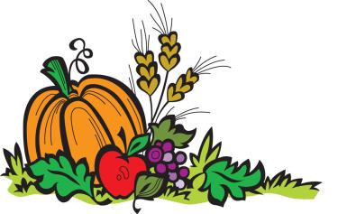  3 | 4
5  Communion Sunday  9:30 AM Adult Sunday School  10:30 AM Worship  6-7:45 PM BYF | 6  7 PM Choir rehearsal  8:30 PM Cantata | 7  9 AM Prayer Group  6:30 PM Book Study  7 PM Music Comm. | 8  7 PM Bible Study | 9  7 PM Praise Band | 10 | 11  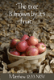
12  9:30 AM Adult Sunday School  10:30 AM Worship  6-7:45 PM BYF | 13  7 PM Choir rehearsal  8:30 PM Cantata | 14  9 AM Prayer Group  6:30 PM Book Study  6:30 PM Trustees  7 PM Deacons  7 PM Missions Brd. | 15  7 PM Bible Study | 16  7 PM Praise Band | 17 | 18
19  9:30 AM Adult Sunday School  10:30 AM Morning Worship  6-7:45 PM BYF | 20  7 PM Choir rehearsal  8:30 PM Cantata | 21  9 AM Prayer Group  6:30 PM Book Study  7 PM Hospitality Mtg. | 22  7 PM Bible Study | 23  7 PM Praise Band  7 PM Baptist Believers | 24 | 25
26  9:30 AM Adult Sunday School  10:30 AM Morning Worship  6-7:45 PM BYF | 27  7 PM Choir rehearsal  8:30 PM Cantata | 28  9 AM Prayer Group  7 PM Brd.. of Christian Ed. | 29  7 PM Bible Study | 30  7 PM Praise Band | 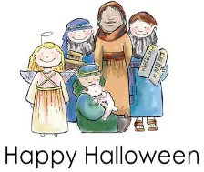  31 | “Live simply, love generously, care deeply, speak kindly, leave the rest to God.”  ―attributed to Ronald Reagan
Church Meetings, Activities & Events

