The Lamplighter
NOVEMBER
2014
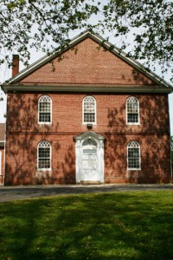
Cohansey Baptist Church

714 Roadstown Road
Bridgeton, NJ 08302
856 – 455 - 7787

Greetings to you in the name of our Lord and Savior Jesus Christ and I trust that this message finds you well and in good spirits! It has been a busy fall season here at the Cohansey Baptist Church and we are excited and glad that God continues to bless and sustain us throughout this year. I was truly humbled and eternally grateful for the love and appreciation showed towards me and my family during the Pastor Appreciation celebration. Words can never express how thankful and grateful, Erika, Alana, Ava, and I are for having such a loving congregation to serve the Lord with.
November is the time of the year when autumn has fully set in and the chill in the air has become more defined. However, it is also the month that brings the promise of my favorite holiday, Thanksgiving. The time honored tradition of food, family, friends, and football is almost here and I can hardly wait! In this season of stuffing and turkey, green beans and sweet potatoes, we must also remember the true meaning of Thanksgiving and that is to give thanks for all of the blessings that we have. I can recall a quote from the entertainment mogul, Oprah Winfrey, who said, “...be thankful for what you have; you’ll end up having more. If you concentrate on what you don’t have, you will never, ever have enough.” What a true statement! All too often we find ourselves recounting the things in life that we don’t have, the places in life that we have never been, the opportunities in life that we have squandered. Instead of focusing our energies on these things, let us use this time to remember all of the ways that God has blessed us through this year and through our lives. How many times has God made a way when it seemed as if there was no way out? How blessed we are to be able to share this holiday season and our lives with people who love and care for us? The clothes on our backs, the food that we eat, the shelter from the rain, God just keeps on blessing us, over and over again.
Throughout this month of November, let us remember the words of 1 Chronicles 16:34, “...give thanks to the Lord, for he is good; his love endures forever.” What a wonderful testimony and a timely reminder that no matter what is happening in life, God never ceases to be good. Beloved, rest in the knowledge that the love of God endures forever, it knows no bounds, it never ceases to be, it is always right here when we need the loving affection of the Father.
I trust that this message blesses and encourages you and I look forward to seeing you in church soon. If I ever be of any service, please do not hesitate to contact the office.

Your Brother in Christ,
Reverend Alexander G. Houston

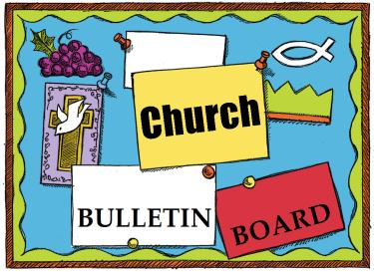
Remember the next newsletter articles, announcements; pictures, etc. are due, November 15, 2014. You can put them in the Newsletter mailbox, email them to me or call me. My email address is: nohowmom@comcast.net and my phone number is 856-455–2574. Thank you!
Thank you to all of those who faithfully give of their time and assemble the newsletter each month.

325th Anniversary
In 2015 our church will be celebrating its 325th year of service to the Lord. We need to start planning for this event, if you would like to be a part of the planning process, please see Penny Timberman.
Cohansey Baptist will be hosting November 10th thru the 15th. This is the first rotation for the Cumberland County Network. They are just getting started and they don’t plan on many families. Pray for Aja Redmond as she starts helping families get back on their feet.

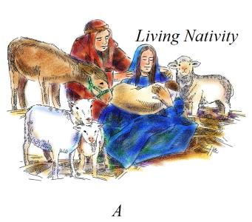
The Hospitality Committee is in need of your HELP!

Saturday, December 6, 2014 6-9PM the Cohansey Baptist Church will hold its first annual DRIVE THRU LIVE NATIVITY

If you would like to volunteer your time to prepare for this joyous event, serve as actors that night or just learn more, please see one of the Hospitality Committee Members:
Brenda Tobin, Emily Mayhew, Linda Turner, Diane Crispin, Sherian Cecchini, Amy Silver, or Penny Timberman
Children’s Christmas
Musical
“Fact or Fiction”
Christmas musical will be on
Sunday December 14th at 6 PM

Hanging of the Greens Sunday, November 30th, 6 PM
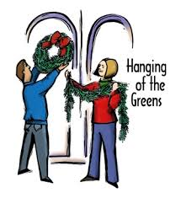

Church Activities and Events (continued)

Sunday November 9th we will have a Friends & Family Day here at Cohansey Baptist. We are asking EVERYONE to bring a friend or a family member with them to Sunday school and church. There will be refreshments and a time to meet Pastor Houston in the Fellowship Hall after church. We encourage you to pray for this Sunday and that God gives you the opportunity to invite someone to come hear His word.

Box City - November 8-9, 2014
For over 20 years, the Jr./Sr. High youth group has sponsored BOX CITY, which is an annual outreach to those who are homeless. During this event, the youth spend the night out in the elements in what they call “home” –a simple cardboard box—to gain a first-hand experience of a taste of what it might be like to be homeless. Please open your hearts and minds in prayer for this ministry and consider giving financially or materially from the following list on Sunday November 9th
Sugar, coffee/tea, spices, cereal, drink mixes, hand soap, shampoo, toothbrushes, deodorant, wash clothes, toothpaste, and towels. Any non-perishable food items, clothing (especially new socks & underwear).
Your donations support the Atlantic City Rescue Mission, which has been providing food, shelter, and spiritual guidance since 1964

Let’s fill some shoe boxes and share the love of Jesus Christ with children around the world who may never hear the Truth any other way!
Here are some suggestions on what to put in your shoe box.
- Toys: Include items that children will immediately embrace such as dolls, toy cars, stuffed animals, kazoos, harmonicas, yo-yos, jump ropes, balls, toys that light up and make noise (with extra batteries), etc.
- School Supplies: pens, pencils and sharpeners, crayons, markers, notebooks, paper, solar calculators, coloring and picture books, etc.
- Non-Liquid Hygiene Items: toothbrushes, bar soap, combs, washcloths, etc.
- Accessories: t-shirts, socks, hats, sunglasses, hair clips, jewelry, watches, flashlights (with extra batteries), etc.
- A Personal Note: You may enclose a note to the child and a photo of yourself or your family. If you include your name and address, the child may be able to write back.
- Do Not Include: Used or damaged items; war-related items such as toy guns, knives or military figures; chocolate or food; out-of-date candy; liquids or lotions; medications or vitamins; breakable items such as snow globes or glass containers; aerosol cans.
Any donations of items or money would be greatly appreciated and the youth will use it toward filling a box during BOX CITY! Please leave your donations on the stage in the Fellowship Hall or see Julie Fleetwood if making a monetary donation by Nov. 2nd.If you are filling a shoe box, please bring it with you to church on Nov. 16th.

2 Garrie Bostwick
Ruth Ewing
7 Cindy DeVol
8 Janet Bonaldo
9 Lorrie DeVol
Vickie Eisenhardt
Paul Levick
11 Jim Bayzick
Vivien Newkirk
Ashley VanMeter
12 Katelyn Bayzick
14 Bruce Sloan
Eddie Thomas
15 Jami Newkirk
18 Steve Sloan
19 Ty Shafer
20 Bethany Weber
22 Renee Bokma
Jamie Foster
23 Hazel Downs
Keith Dunkleberger
Ian Willis
24 Holli Olbrich
26 Craig Williams
Sandi Bonham
Brett Smick
27 Sam Guy
28 Matt Lucas
29 Dot Lewis

****If your name is not on our Birthday List or there needs to be a correction or your name has changed please let me know by calling 856-455-2574 or by email at nohowmom@comcast.net. Thank you****

Special Dates

• All Saints’ Day, November 1, 2014
• Daylight-Saving Time ends, November 2, 2014
• Veterans Day, November 11, 2014
• Christ the King Sunday, November 23, 2014
• Thanksgiving, November 27, 2014
• First Sunday of Advent, November 30, 2014

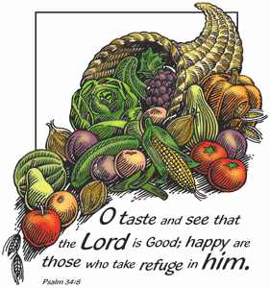

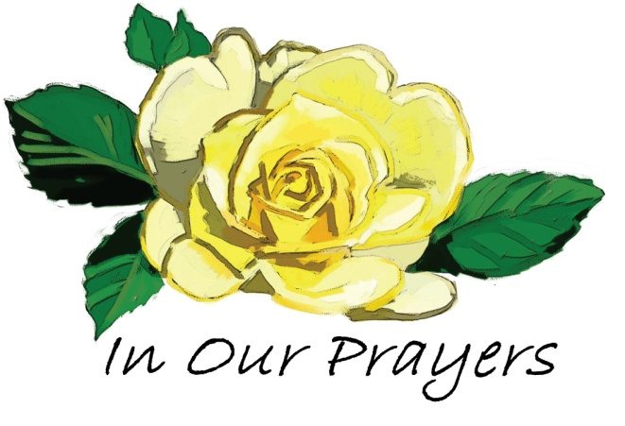

Please keep these people in prayer That God may manifest His healing in them and He will be praised.

Irene Vetro R.C. Holt Bill Felmey Rose Gaggini George Moore Leon Fithian Timothy Ross Carol Shimp Baby Alice Uhland Evelyn Armstrong Princeton Dozier Bob Turner Mary Houston Dot Turner Erica Houston
Prayers of sympathy for the Guth family. Their mother Gladys B. Guth has gone home to glory.
Prayers of sympathy for Sallie Counsellor whose sister, Nancy Hitchner went home to be with the Lord.
Prayers of praise for Spencer Willis and Lauren Johnson on the birth of their daughter, Madelyn Elizabeth Willis on October 21, 2014.
Please pray for the well-being of our country and our leaders. May God grant them wisdom as they deal with the situations around the world and here at home.
Shut-Ins: Janet Bonaldo Ashley Guntow Ruth Levick Doris Newkirk
Nursing Homes: Anna Dickerson Margaret McAllister
Battling Cancer: Gloria Branca Lisa Haffner Emily Horton Debbie Marks Lake Jeff Mortimer Marion Nickopolous Louise Orsini Ed Peterson Ron Rouver Mike Scavelli Brenda Snyder Aaron Silver, Jr.
Serious Condition: Dave Borrelli
In the Service: Mike Dunkelberger Kyle Mihalecz Nicky Mihalecz Brian Schrier Doug Shimp Russell Shinn Shauna Sloan Andrew Tobin Lance Shestakoff Jay Perticari
College Students: Tyler Davenport Amaryllis DeJesus Katelin Elwell Steve Frantz David Johnson Mindy Williams Samuel Tobin Megan West Melissa Smith Megan Smith

Give Thanks Always
Full many a blessing wears the guise
of worry or of trouble;
Far-seeing is the soul, and wise,
who knows the mask is double.
But he who has the faith and strength
to thank his God for sorrow
Has found a joy without alloy
to gladden every morrow.
—Ella Wheeler Wilcox
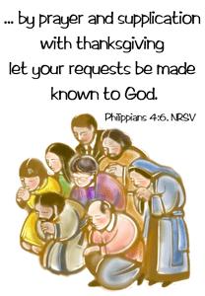

Recipe of the Month:
Cinnamon Bun Cake
Base:
3 cups flour
1/4 teaspoon salt
1 cup sugar
4 teaspoons baking powder
1 1/2 cups milk
2 eggs
2 teaspoons vanilla
1/2 cup butter, melted
Topping:
1 cup butter, softened
1 cup brown sugar
2 tablespoons flour
1 tablespoon cinnamon
Glaze:
2 cups icing sugar
5 tablespoons milk
1 teaspoon vanilla
Preheat oven to 350F. Prepare a 9 x 13 baking pan (buttered).
Mix all of the base ingredients together, with the exception of the butter. Add the melted butter last, and then pour into your prepared pan,
Mix all of the topping ingredients together in a separate bowl. Mix well. Drop by teaspoonful over the base, as evenly as you can over the entire base. Take a butter knife and swirl the topping into the base. Pop into the oven and bake for 28-30 minutes.
While the cake is baking, prepare the glaze and set aside.
Remove from oven and glaze the cake while still warm.
Gratitude gets us through the hard stuff. To reflect on your blessings is to rehearse God’s accomplishments. To rehearse God’s accomplishments is to discover his heart. To discover his heart is to discover not just good gifts but the Good Giver.
Gratitude always leaves us looking at God and away from dread. It does to anxiety what the morning sun does to valley mist. It burns it up.
—Max Lucado, You’ll Get Through This

Memory Verse:
Sing unto the Lord with thanksgiving;
Sing praise upon the harp unto our God.
~Psalm 147:7

Jokes:
Q. What do dogs and trees have in common?
A. Bark.
Q. What do you call a kangaroo that sneezes alot?
A. A kanga-choo.
Q. A tomato, a cabbage and a hose were in a race. The tomato was red and the cabbage was a vegetable. Who won?
A. The hose was running, the cabbage was a head and the tomato was trying to ketchup.

Puzzle:
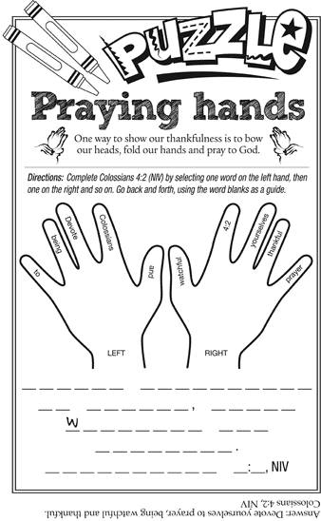
Bible quiz:
What was the source of Samson’s strength?
A. His huge muscles
B. The Spirit of God
C. His uncut hair
D. He inherited it from his father
Answer: (See Judges 14:19.)

How Many Socks Do You Have?

Do you have a sock drawer? Do you have socks for keeping warm, dressing up, working out? Socks that coordinate with your outfit or maybe that you rarely wear? God is so good in supplying all of our needs.

The Missions Board is collecting new socks. They will go to multiple groups, depending on need: Code Blue (homeless mission in Bridgeton) - Baptist Children's Services - First Crow Baptist Church in Montana - Atlantic City Rescue Mission - etc.

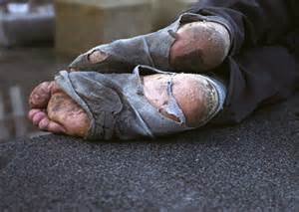

Most needed is new men's socks but we will gladly accept any new socks. A container will be at the front of the sanctuary by the organ. Or see Dee Johnson, Nancy Baker, Diane Smith, Pat Springer.

As you are able, we pray that our church family at Cohansey Baptist will help contribute in this small way to help others this winter.

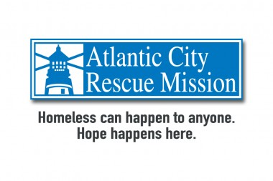
Help is needed to keep our building heated, cooled, ventilated, and to keep the lights on. Direct Install is a program that has been offered, accepted and approved to the Mission. If the Mission pays 30% of upgrade costs, an energy grant will pay the remaining 70%. Not only will aging equipment be upgraded, but future utility costs will be significantly lowered due to higher efficiency. Your gift to this project will have long-lasting effects on the poor and needy in our community and state.
As we head into another winter season, would you consider a gift to help make this project a reality? Funds (with a notation "Direct Install") can be sent directly to ACRM PO Box 5358 Atlantic City NJ 08404 - or given to a Missions Board member to be forwarded.

Call the Mission at 609-345-5517 x 116 if you have any questions about this or any other ACRM ministry. Thank you and God bless you.

Our Recent "America For Christ" Offering

We recently participated in the annual "America For Christ" offering through "American Baptist Home Mission Societies". As you may recall, this year's theme was "Seek Justice", based on Isaiah 1:17, which states: Learn to do good; seek justice, rescue the oppressed, defend the orphan, plead for the widow". As followers of Christ, we represent the promise of God's love to our world by participating in the building up and strengthening of our communities - bearing witness to the gospel of Christ that brings hope and justice.

Cohansey Baptist Church ranked among the top 250 contributing churches for the 2014 AFC offering. Thank you all for your continuing generous and prayerful support for this outreach.

Election Year Advice
In 1774, John Wesley, co-founder of the Methodist Church, offered this advice to people who’d be voting:
• Vote, without fee or reward, for the person you judge most worthy.
• Speak no evil of the person you vote against.
• Take care your spirits aren’t sharpened against those who voted on the other side.

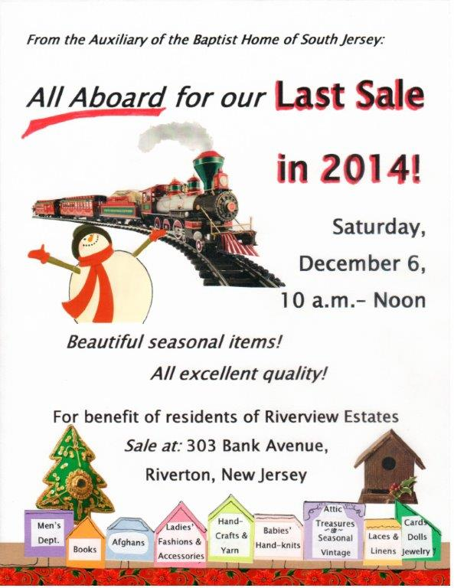
Something's Fishy
On her blog “Tales of Wonder,” Marlo Schalesky writes about the short-lived goldfish her family has accumulated over the years. When her daughter brought two more home, Schalesky tried to lower her expectations: “Fish like this don’t live that long.” Yet those particular fish thrived — one lived five years! Schalesky figured their well water must have been purer than the city water their previous pets inhabited.
People are like fish that way, Schalesky suggests: What surrounds us has power over us. Constantly “swimming” in negativity and impure thoughts hinders our growth and well-being. Yet if we seek Christ-like surroundings, we’ll thrive spiritually.
“Whatever is true, whatever is noble, whatever is right, whatever is pure, whatever is lovely, whatever is admirable — if anything is excellent or praiseworthy — think about such things” (Philippians 4:8, NIV).

Returning Thanks
After a family sat down for breakfast, the father offered his standard prayer of thanks. Afterward, though, he began his usual grumbling about financial hardships, the food’s poor quality, how it was cooked and so on.
One of his children interrupted: “Dad, did God hear what you said a while ago when you were giving thanks?”
“Certainly,” the father replied confidently.
“And did he hear what you said just now about the bacon and the coffee?”
“Of course,” the father said, more hesitantly.
“Which did God believe?”

SUNDAY | MONDAY | TUESDAY | WEDNESDAY | THURSDAY | FRIDAY | SATURDAY
For your countless blessings, God, we thank you. May we always use them to bless others. |  |  |  |  |  | 1
2  Communion Sunday  9:30 AM Adult Sunday School  10:30 AM Worship  4-5 PM Kids Musical Rehearsal  6-7:45 PM BYF | 3  7 PM Choir rehearsal  8:00 PM Cantata | 4  9 AM Prayer Group  7 PM Music Comm. | 5  10:30 AM Manor Service  7 PM Bible Study | 6  7 PM Praise Band | 7 | 8
9  9:30 AM Adult Sunday School  10:30 AM Worship  4-5 PM Kids Musical Rehearsal  6-7:45 PM BYF | 10  7 PM Choir rehearsal  8:00 PM Cantata | 11  9 AM Prayer Group  6:30 PM Trustees  7 PM Deacons  7 PM Missions Brd. | 12  7 PM Bible Study | 13  7 PM Praise Band | 14 | 15
16  9:30 AM Adult Sunday School  10:30 AM Morning Worship  4-5 PM Kids Musical Rehearsal  6-7:45 PM BYF | 17  7 PM Choir rehearsal  8:00 PM Cantata | 18  9 AM Prayer Group  7 PM Hospitality Mtg. | 19  7 PM Bible Study | 20  7 PM Praise Band  7 PM Baptist Believers | 21 | 22
23/30  9:30 AM Adult Sunday School  10:30 AM Morning Worship  4-5 PM Kids Musical Rehearsal  6-7:45 PM BYF | 24  7 PM Choir rehearsal  8:00 PM Cantata | 25  9 AM Prayer Group  7 PM Brd.. of Christian Ed. | 26  7 PM Bible Study | 27 | 28 | 29  As Christmas draws near, remind me, Jesus, to make time for quiet anticipation of your coming.
CHURCH ACTIVITIES AND EVENTS

