The Lamplighter
MAY 2014
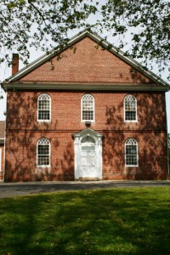
Cohansey Baptist Church

714 Roadstown Road
Bridgeton, NJ 08302
856 – 455 - 7787

Greetings to you in the name of our Lord and Savior Jesus Christ! I pray that this message finds you well and in great spirits as we continue to be blessed by our wonderful God. April was a fantastic month at the Cohansey Baptist Church highlighted by our joint Lenten services and a wonderful Resurrection Sunday morning. Our choir prepared and ministered a moving cantata this year and I encourage anyone who missed it to make plans to be there for next year because it was simply fabulous. Easter sunrise service was well attended and we were treated to a scrumptious pancake breakfast afterwards prepared by the men of Cohansey. We ended the day with a full house for morning worship and I believe it is safe to say that all who attended were blessed and encouraged.
On another note, our picture directory continues to move forward and we have ended the period of picture taking. I am most definitely looking forward to seeing all of your smiling faces on the pages of this piece of history! As I am writing this, I am in Washington DC, gathering with a group of young pastors from across the country, for a time of learning, fellowship, and study, I ask that you continue to keep me in prayer as I seek to grow, learn, and further live out the calling of God on my life.
As I continue to reflect on the resurrection of Jesus Christ, I am ever thankful that when He left this earth He did not leave us alone. No my friends, Jesus said, “...and I will pray the Father, and he shall give you another Comforter, that he may abide with you forever.” (John 14:16) It is such a reassurance that the Holy Spirit is with us now and forever. The Spirit is here to comfort us, to direct us, to convict us, to serve as an advocate for us, we are never alone! From time to time in life we may feel as if we are alone and that no one truly understands our situations, insecurities, shortcomings, or secret desires of our hearts; but Jesus has said there truly is someone who understands, the Holy Spirit. Allow me to encourage you to be silent and bask in the glow of the Spirit, to listen intently to what might be being said to you in times of needed direction, and to thank Christ that He has followed through on His promise and that the Spirit now lives with us and inside of us.
I trust that this message blesses and encourages you and if I can ever be of service, please let me know. God bless you and keep you and I look forward to seeing you in church soon!

Your brother in Christ,
Reverend Alexander G. Houston
Pastor

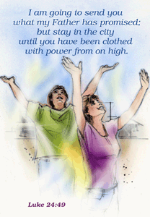

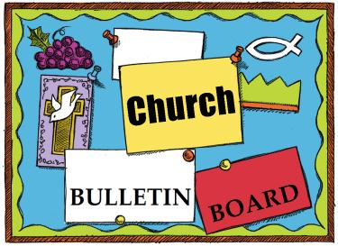

Remember the next newsletter articles, announcements; pictures, etc. are due, MAY 15, 2014. You can put them in the Newsletter mailbox, email them to me or call me. My email address is: nohowmom@comcast.net and my phone number is 856-455–2574. Thank you!
Thank you to all of those who faithfully give of their time and assemble the newsletter each month.

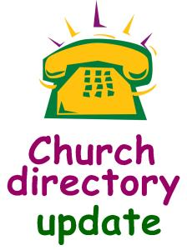
The CE Board wants all parents of small children to know that there is a Nursery provided during the worship service. The Nursery attendants are now CPR certified.

Calling all church members! Don’t forget the Annual Business Meeting to be held on Friday, May 9th at 7 PM in the sanctuary. Let your voice be heard and your vote count! Looking forward to seeing you there.

Cohansey Baptist will be hosting Vacation Bible School the week of June 23rd thru the 27th, 2014 and we are looking for volunteers. Volunteering at Vacation Bible School can be one of the best experiences that you can have. There are many ways for you to use your talents to help with VBS; food, crafts, guides, singing, and by just being an example of Christ to them. It’s an opportunity that allows you to feel good, because you can help children learn about God in a way that is fun for them. To find out how you can help see Andrea Levick.
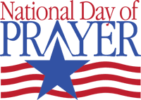
The Shiloh Seventh Day Baptist at 116 East Avenue, Shiloh, NJ 08353 will be holding a National Day of Prayer Service on May 1, 2014 at 6:30 PM. The guest speaker will be the Rev. Dave Bailey from Ranch Hope and music will be provided by Terri Bodine. Light refreshments will be served. For more information call Charlotte Chroniger at 856-455-0488.

Just want to say “Thank you” to Sharon Guth for taking pictures and to all of those who came out to have their pictures taken for the new church directory. We will keep everyone informed when the directory is finished.
On Sunday, May 4th, 2014 our West New Jersey Baptist Association Annual Meeting will celebrate 203 years of sharing the message of the Gospel in ministry together at the First Baptist Church in Salem. The meeting will be followed by dinner the cost of which is $8.00. If you are planning to attend please call 856-935-0531. Registration is at 3 PM, Worship at 3:30 PM, 4:30 PM Business meeting and 5:30 PM Dinner.

- Tammy Holt
- Jordan Guy
Susan Perry

4 Genevieve Fernandez

- Lisa Fernandez
- Michaela Hitchner
- Brian Crispin

10 Jeanne Haberler

11 Cliff Jones

13 Seth Hitchner
14 Vera Mayhew

Shauna Sloan
Donna VanMeter

15 Joshua Weber

18 Valerie Perry

Weston D. Guy
19 Katelin Elwell
- Andrea Bostwick Lucas
23 Cheryl Mayhew
24 Irving M. Gandy V

31 Bill King

****If your name is not on our Birthday List or there needs to be a correction or your name has changed please let me know by calling 856-455-2574 or by email at nohowmom@comcast.net. Thank you****

Special Dates
• National Day of Prayer, May 1, 2014
• Christian Family Week, May 5-11, 2014
• Mother’s Day, May 11, 2014
• Armed Forces Day, May 17, 2014
• Victoria Day (Canada), May 19, 2014
• Memorial Day, May 26, 2014
• Ascension of the Lord, May 29, 2014

Celebrating Mom
In spring 2013, a young man named Aba Atlas wanted to do something special for his birthday, so he gave his mom a present — and made a video about the gift and its beloved recipient. (Locate it on YouTube by searching for “iProjectAtlas, Dear Mother.”)
For years, Aba’s mother had worked long hours outside the home and then cared for her kids each evening. She’d bought a house so her children would always have a place to call home, yet the mortgage caused her great stress. Working at a $30,000/year position, Aba saved enough money to pay off his mom’s mortgage and, on his birthday, presented her with a check. According to a caption in the video, her response was “Wow x 9000.”
“I want to celebrate my life by celebrating the woman who gave me life,” Aba says.

Please keep these people in prayer as they deal with various physical problems. Pray for healing and complete recovery.
Irene Vetro R.C. Holt Evelyn Armstrong Bill Felmey Rose Gaggini George Moore Polly Davenport Donna Loud Gladys Guth Timothy Ross Pray for those whose lives have been affected by the tornados.
Prayers of Praise:
Helen Rammel is home after being treated for a heart problem.
Evered Levick, Sr. who celebrated his 90th birthday in April.
Dennis Gaggini who had a reaction to treatment and is now home and doing well.
Alice Angel Uhland came home from the hospital. She was born 4 months premature. Continue to pray for her and her parents.
A Family that stayed at our church thru Family Promise now has a home.
For the beauty of our sanctuary on Easter Morning.
Please pray for the well-being of our country and our leaders. May God grant them wisdom as they deal with the situations around the world and here at home.
Congratulations to Roger and Ashlea Riggins who welcomed a new baby girl into the world on April 23, 2014. Her name is Joanna Renee, she weighed 7 lb. 1 oz. Congratulations to her grandparents, Bob and Donna Riggins.
Shut-Ins: Janet Bonaldo Ashley Guntow Arthur Levick Ruth Levick Doris Newkirk
Retirement Homes:
Nursing Homes: Don Brammer Anna Dickerson Margaret McAllister
Battling Cancer: Gloria Branca Lisa Haffner Emily Horton Debbie Johnson Giavana Krumaker Jonathan Lopez Debbie Marks Lake Jeff Mortimer Marion Nickopolous Jose` Nieto Louise Orsini Ed Peterson Ron Rouver Mike Scavelli Brenda Snyder Paige Whitesell
Serious Condition: Dave Borrelli
In the Service: Mike Dunkelberger Ryan Fithian Kyle Mihalecz Nicky Mihalecz Brian Schrier Doug Shimp Russell Shinn Shauna Sloan Andrew Tobin Lance Shestakoff
College Students: Tyler Davenport Amaryllis DeJesus Katelin Elwell Steve Frantz David Johnson Mindy Williams Samuel Tobin Megan West
Prayer is the saucer into which parental fears are poured to cool. … Each time a parent prays, Christ responds. His big message to moms and dads? Bring your children to me.
—Max Lucado, Fearless

Recipe of the Month:
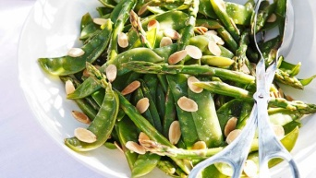
Asparagus salad with Peas and Almonds
INGREDIENTS

½ cup flaked almonds
4 bunches asparagus, trimmed
500g snow peas, trimmed or 1 cup of fresh peas shelled out
Iced water
Salad dressing
3 tbsp extra virgin olive oil
1½ tbsp white balsamic vinegar
1 small garlic clove, minced
Sea salt & cracked black pepper
METHOD

Boil water Bring saucepan of salted water to boil.
Toast almonds Meanwhile, in frying pan toast almonds for 4 mins over medium-high heat until fragrant and lightly golden, tossing regularly.
Blanch vegies Blanch asparagus in boiling water for 2 mins, then add snow peas. Cook for 1 min. Drain and plunge vegies into bowl of iced water to set colour and stop cooking process. Drain well.
Make dressing Combine oil, vinegar and garlic in bowl. Season with salt and pepper to taste. Place vegetables on platter, drizzle with dressing and scatter over toasted almonds.
As I embark on this new adventure on this journey we call life, I am finding it difficult to find words to express my thoughts and feelings. Left to my own devices I would not have chosen this adventure, but it was not my choice, but His. Therefore I must accept this new adventure and all of the challenges it may bring with renewed faith and hope. Howard said from the beginning, that no matter the outcome, he was in a win/win situation. I believe that he knew long before the rest of us that he would soon be going home. His positive attitude and peace helped me to find peace and comfort.
As a family we have been overwhelmed with the outpouring of love that we’ve seen. The cards, notes, calls, food, donations, visits and prayers have been a blessing to each one of us. And don’t think that all of those prayers you laid at the feet of Jesus went unanswered. Howard has the most complete and beautiful healing anyone could ever ask for, he now has a whole new body!
We have said many times that we don’t know how people who don’t know the Lord or have a caring and loving church family get through the difficult times in life. Trying to find the words that let you know just how much we appreciate all of you is not easy and “thank you” just doesn’t seem to be enough. For now “thank you” will have to do to express our gratitude.
I love you all and pray that God continues to richly bless you.
Nola and Family

Memory Verse:

I laid me down and slept; I awoke;
for the Lord kept me.
~Psalm 3:5

Jokes:
Q. What's the difference between winter and a hurt football player?
A. One is cold out and the other one is out cold.
Q. What do you get if you cross a porcupine and a giraffe?
A. A seven metre long toothbrush!
Q. You have a candle, a stove, and a fireplace and a match. Which one would you light first?
A. The match!

Puzzle”
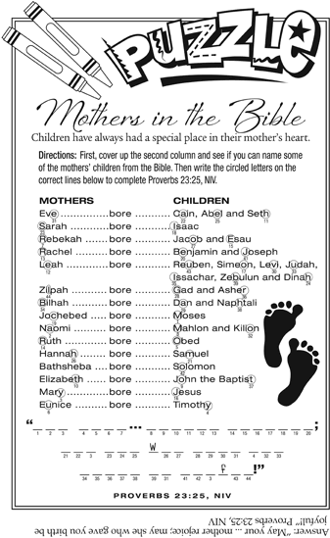

Bible quiz:
Complete the following Bible verse: “A gentle answer turns away _____, but a harsh word stirs up _____.”
A. an argument; obedience
B. wrath; anger
C. jealousy; resentment
D. falsehood; truth
Answer: (See Proverbs 15:1, NIV.)

.

My Mission Field

Where is MY mission field? Is it through giving? Is it in the local community? Family Promise? AboutFace? Volunteering? Nationwide? Globally?

Regardless of how you give or participate in the Lord's command to "love our neighbor as yourself", please pray for God's guidance as we each, individually, strive to do His calling on earth. Pray that all missionaries in the field will be blessed in their work. Pray that the monies and other resources we give through our offerings at Cohansey Baptist will be used to God's glory. Pray that those whose lives are touched will come to know the saving grace of Jesus Christ. Pray that we each earnestly seek God's direction as we serve Him.

You, God are my God, earnestly I seek you;
I thirst for you, my whole being longs for you
in a dry and parched land where there is no water.
I have seen you in the sanctuary and beheld your power and your glory.
Because your love is better than life, my lips will glorify you.
I will praise you as long as I live, and in your name I will lift up my hands.
I will be fully satisfied as with the richest of foods;
with singing lips my mouth will praise you.]
On my bed I remember you; I think of you through the watches of the night.
Because you are my help, I sing in the shadow of your wings;
I cling to you; your right hand upholds me.
Psalm 63: 1-8

Mission Views and News
A good way to discern God’s perspective and intentions is to participate in God’s activity. (From Karen-Marie Yust, Attentive to God, p. 13)
It is in acting with God that we most fully experience God as active in the world. When we feed the hungry, clothe the naked, listen to the discouraged, comfort the grieving, set free those imprisoned by the injustices of our society, and otherwise follow the example of Jesus, we learn about God’s will by doing God’s will. We . . . discover what it means to think and act with the mind of Christ. As we act with God, we are moved to envision new possibilities for future actions and different ways of being in the world. A missional church is a community sent out to its local context. It is centered on God’s mission rather than on itself or its own survival. Becoming a missional church means switching from the mentality of “come to us” to one of “go to them” and from “come and see” to “go and be.”
Read 1Cor. 12:1-11 about spiritual gifts and ask God what your calling is. Don’t be afraid to say, “Here I am, Lord.”
Baby Bottle Boomerang!
The Cornerstone Women’s Resource Centers are holding their Baby Bottle Boomerang. Be sure to pick up an empty bottle on Mother’s Day and return it filled with your donation by Father’s Day to help ensure a safe and happy beginning of life for some area babies. Learn more about Cornerstone on the web at: www.cornerstonewrc.org.

SUNDAY | MONDAY | TUESDAY | WEDNESDAY | THURSDAY | FRIDAY | SATURDAY
“A child needs your love most when he deserves it least.”  —Erma Bombeck |  |  |  | 1  7:30 PM  Praise Band Rehearsal | 2 | 3
4 Communion Sunday  9:30 AM Sunday School  10:30 AM Morning Worship  6:30 – 7:30 PM BYF | 5  7 PM Choir | 6  9 AM Prayer Group  7 PM Music Comm. | 7  10:30 AM Manor  7 PM Bible Study | 8  7:30 PM  Praise Band Rehearsal | 9  7 PM Annual Business Meeting | 10
11  9:30 AM Sunday School  10:30 AM Worship  NO BYF | 12  7 PM Choir | 13  9 AM Prayer Group  6:30 PM Trustees  7 PM Deacons  7 PM Missions Comm. | 14  7 PM Bible Study | 15  7:30 PM Praise Band Rehearsal | 16 | 17
18  9:30 AM Sunday School  10:30 AM Morning Worship  Last BYF | 19  7 PM Choir | 20  9:00 AM Prayer Group | 21  7 PM Bible Study | 22  6:30 PM White Cross  7:30 PM  Praise Band Rehearsal | 23 | 24
25  9:30 AM Sunday School  10:30 AM Morning Worship | 26 | 27  9 AM Prayer Group  7 PM Brd. of Christian Ed. | 28  7 PM Bible Study | 29  7:30 PM Praise Band Rehearsal | 30 | 31  Each new day to praise your name is a glorious gift, Lord. Thank you!
MAY 2014 Church Meetings, Activities & Events

