The Lamplighter
JULY 2013
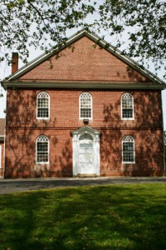
Cohansey Baptist Church

714 Roadstown Road
Bridgeton, NJ 08302
856 – 455 - 7787

Greetings in the name of our Lord and Savior Jesus Christ! I trust that this message finds you well and in great spirits! I am excited to report that summer is here and the weather is heating up. With the coming of summer was the 2013 launch of Vacation Bible School. For one week, over fifty youth gathered at the Cohansey Baptist Church for a wonderful time of singing, learning, playing, arts and crafts, along with a host of other activities. The Christian Education Board along with a large number of volunteers did an outstanding job of preparing an exciting week of learning for all of the kids who participated.
On July 4th, 2013 we will celebrate Independence Day commemorating the adoption of the Declaration of Independence. It is always chilling to think of the strength and vision that the original signers of the Declaration possessed. Although they were not perfect men, they did have the wherewithal to live out the mantra echoed by the great statesman from Virginia, Patrick Henry, “…give me liberty, or give me death!” Let us never forget that freedom is never gained without a cost. As the fledgling nation opposed tyranny and committed to freedom, the pathway to independence was gained with the blood of patriots beginning with Crispus Attucks, the first man killed in the Boston Massacre.
In the book of Galatians, the apostle Paul reminds us that freedom is not just something that we enjoy as citizens of the United States of America but also a benefit from being in the body of Christ. “It was for freedom that Christ set us free; therefore keep standing firm…” (Galatians 5:1) Christ came in order that we might be free from the law of sin and death and recipients of the law of grace. Christ came that we may have freedom from hell and a pathway to heaven.
Similarly, our salvation and freedom was paid for by the blood of Jesus, “…knowing that you were not redeemed with perishable things like silver or gold…but with precious blood…the blood of Christ.” (1 Peter 1:18-19) Christ bled and died that we might be free and we must always honor and thank Him for His sacrifice. On this July 4th, remember and give thanks for those who sacrificed that we might live in freedom; however, never forget the ultimate freedom that Christ has bestowed on us His children.
I trust that this message blesses you and I look forward to seeing you in church soon.

In His Service,
Rev. Alexander G. Houston
Pastor
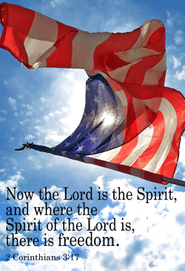

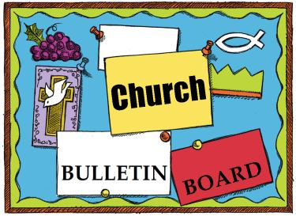
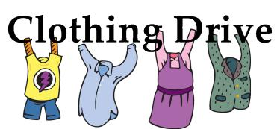

Remember the next newsletter articles, announcements; pictures, etc. are due, August 15, 2013. You can put them in the Newsletter mailbox, email them to me or call me. My email address is: nohowmom@comcast.net and my phone number is 856-455–2574. Thank you!

Thank you to all of those who faithfully give of their time and assemble the newsletter each month.
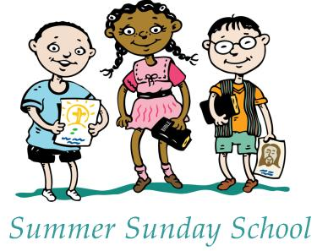
Every Sunday at 9:30am
Attention Adults
Feel free to join a combined adult Sunday School during the summer months in the Fellowship Hall. We will be continuing our Faithweaver® series, which focuses on growing a relationship with Jesus Christ.
Attention Youth
Youth ages K thru those going into 4th will continue to meet downstairs in the Education Building. Youth going into 5th thru 12th grade will meet upstairs in the parsonage. They will also continuing the Faithweaver® curriculum.

The ABOUTFACE committee is collecting:
- Wearable & Used Clothing (men’s, women’s, & children’s)
- Shoes, belts, handbags, hats, scarves, ties, etc.
- Household items (bedding, curtains, towels, pots & pans)
- Toys (soft toys, hard toys, bicycles of any size) Hard toys should fit in a box 24” x 24”
ABOUTFACE will receive money for every pound we collect. Please put all items that you are donating into tied plastic bags.
WHEN: We are collecting until August 15th.
DROP OFF: All items can be left in the Sunday school class in the Education building (downstairs, third door on right), or on the back porch of parsonage in tightly tied bags.
These items will go to those in need within the U.S and many other parts of the world.
I just want to take a moment to thank everyone for their prayers, cards, phone calls, and encouragement. I also want to thank the Workers for Christ Class for the beautiful flowers and the Pastor for his visits. We are still trying to get the pain under control. I have several doctors to see in the next couple of weeks and hope that we can figure out the cause and take care of it. I ask for your continued prayers and praise God for such a caring church family.
Nola Willis

BIRTHDAYS
1 Annie Holt
3 David Bostwick, Jr.
Lucas Gregory
Linda Halter
Zachary Hitchner
4 Briana Sebastian
Lil Evans
6 Darlene LaFleur
Roger Riggins

8 Clayton Guy
Jon C. Marks
9 Carrie Johnson
10 Diane Levick
Ed Guth
11 Gary Van Meter, Jr.
12 Joey Wagner
Hope Zeck
13 Tara Hitchner
Ruth Levick
14 Michael Marino
Sherian Joyner-Cecchini
15 Dee Johnson
16 Harriet Levick
Sara Foster
17 Nicole Turner
Marc Marino
19 Kelly Shinn
20 Lester Shimp
Jodi Wagner
21 Rhonda Shafer
22 Nola Willis

23 Dorothy Elwell
26 Matthew Clark
Michelle Barnes

Abigail Riggins
Spencer Willis

27 Helen Sloan
29 Phyllis Bickley
30 Aaron Silver
Patti Tobin
31 Ken Olbrich
Ed Smith
Bryce Andrew Smick

****If your name is not on our Birthday List or there needs to be a correction or your name has changed please let me know by calling 856-455-2574 or by email at nohowmom@comcast.net. Thank you****

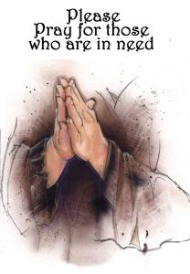
Please keep these people in prayer as they deal with various physical problems. Pray for healing and complete recovery.
Frank Stanfa Doris Newkirk Don Stanson Irene Vetro John Carman Jana Carman Bud Newkirk Betty Jones Gloria Levick Fred Athey Mary Houston Gordon Houston Nola Willis Jason and Anita Notoro
Please pray for comfort and strength for these families who have lost loved ones.
Helen and Donald Sloan in the passing of Helen’s sister Betty.
Please pray for the well-being of our country.
Shut-Ins: Janet Bonaldo Ashley Guntow Arthur Levick
Retirement Homes: Ed Smith
Nursing Homes: Don Brammer Anna Dickerson Ruth Levick Jeanette Merritt Margaret McAllister Alice Moore
Battling Cancer: Jayme Bickings Gloria Branca Cindy Frederick Mildred Gibe Lisa Haffner Emily Horton Debbie Johnson Giavana Krumaker Tom Laquitara Jonathan Lopez Debbie Marks Kale Jeff Mortimer Marion Nickopolous Jose` Nieto Louise Orsini Jerry Oswald Ed Peterson Ron Rouver Mike Scavelli Brenda Snyder Paige Whitesell Jayme Wright
Serious Condition: Dave Borrelli
In the Service: Mike Dunkelberger Ryan Fithian Andy Guth Kyle Mihalecz Nicky Mihalecz Brian Schrier Doug Shimp Russell Shinn Shauna Sloan Jamili Andrew Tobin Lance Shestakoff
College Students: Katelyn Bayzick Tyler Davenport Amaryllis DeJesus Ashleigh Elwell Sheli Loud David Johnson Sean Pedrick Ashley Shafer Jeremy Shafer Samantha Tobin Samuel Tobin Zack Tuthill Josh Weber Megan West

The Importance of Prayer
Prayer is the Christian’s life. Though every other ordinance be attended to, yet if this one be neglected, all is in vain. It is as impossible for the soul to be spiritually alive and active without a punctual course of fervent and believing prayer, as for the body to be alive and active without breath.
Prayer has more influence on the sanctification of the soul than all other ordinances. It is going directly to God to receive the life-giving Spirit according to an absolute and often repeated promise: “Ask, and it shall be given to you; seek, and ye shall find; knock, and it shall be opened unto you.”
—Edward Griffin

Update on Crochet / Sewing / Craft Projects
A group of folks have been meeting over the last year to work on multiple craft projects. We have sewn baby booties, hats, and gowns - collected and prepared old bed sheets to roll into bandages for use in third world countries - crocheted baby blankets and lap afghans for senior citizens. Currently we are making denim patchwork quilts for our Family Promise families.
By the time you are reading this, we will have sent another batch of crocheted blankets to Cornerstone Women's Center, (our local pregnancy help organization) and to the Crow Indian Reservation in Lodge Grass Montana - hand delivered by our friend, Pam Smith, her daughter, Tara Garton, and grandson, Benjamin.
If you would like to come out for a fun evening of fellowship and the opportunity to help others, we meet on the fourth Thursday of most months at 6:30 pm. If you would like to donate any finished items or materials, ie yarn, denim, fabric - please see Dee, Nancy, Emily, Pat, Dottie, Connie, Sharon, or Amy.

2 Corinthians 8:11
Now finish the work, so that your eager willingness to do it may be
matched by your completion of it, according to your means.

What Is YATMA?
The American Baptist Churches of Pennsylvania (ABCOPAD), the American Baptist Churches of New Jersey (ABCNJ) and the Philadelphia Baptist Association together with the support of The Virginia and Gordon Palmer, Jr. Trust Grant Program of the American Baptist Foundation has made it our goal to begin a collaborative ministry using online education tools, social media networking and educational/ministry gatherings to start an ongoing ministry with the sole purpose of reaching 18-29 year olds. The basis of this ministry will be established to help churches understand what this age group deems important to our world and how it intersects and connects them to Christ's prophetic words of "take care of the least of these."

The Impact
Our regions combined, represent over 700 congregations. We believe the possibilities of impact can be far reaching. We hope to see:
- A growing desire by our congregations to reach 18-29 year olds.
- A movement by churches to combine young adults' desire for service with connecting points to faith experiences.
- More young adults attending church and/or in ministry service opportunities.
- More utilization of online tools by our congregations for ministry purposes.
- A mentorship program developed where 18-29 year olds serve a younger generation and/or generations above are mentoring 18-29 year olds.

How Can You Get Involved?
Our greatest desire is an effort to bring a diverse group of people together to connect and share common ministry values to better serve, rebuild and retain 18-29 year olds in the local church.

We are looking to bring together a committed group that will become the CORE planning team, for the strategic launch of this ministry, and eventually will become the "area consultants" for the training and sharing of ideas. The pre-planning will begin in August 2013 with 18-29 year olds along with other adults to make sure we hear from all those we serve and those who serve. This group should include a diverse group of people across generations, genders and ethnicity.

If you feel that God is calling you to participate in this exciting new ministry, please contact Pastor Houston, Dee Johnson or any member of the Missions or Christian Education Committees.

Recipe of the Month

It’s too H-O-T to cook! How about whipping up an ice cream pizza?

Ingredients:
1 quart of ice cream
2 jars of ice cream topping (strawberry, cherry)
2 squares of white chocolate
Toppings such as banana slices, strawberries, cherries, M&M’s, gummy bears, dots, jimmies
1 pizza pan (you can get one at the $ store.

Preparation:
1. Let ice cream soften a bit then spread an even layer in the pizza pan to create a crust. Freeze in the freezer for about an hour until very firm.
2. Spread the strawberry topping (or topping of your choice) evenly on the ice cream crust leaving about a ½ inch border around the edge. Put back in freezer for ½ hour.
3. Using a vegetable peeler, shave pieces of chocolate onto the pizza.
4. Top with fruit or candy and put back in the freezer until you are ready to serve the pizza.
5. When ready to serve cut with a pizza cutter just like a regular pizza. Enjoy
A Little Heavenly Humor
A Sunday School teacher began her lesson with a question, "Boys and girls, what do we know about God?"
A hand shot up in the air. "He is an artist!" said the kindergarten boy.
"Really? How do you know?" the teacher asked.
"You know - Our Father, who does art in Heaven... "
Cemetery Notification
Cohansey Baptist Cemetery lots will increase
effective September 1, 2013
Anyone interested in purchasing lots at the old rate will be able to do so prior to September 1, 2013.
Please contact Ben Turner at 609-774-0812 after 5:00 p.m.
Or at turner6178@aol.com.

Old Rates Effective until 8/31/2013
- Full lot with 5 graves purchased by a church member $500.00
- Full lot with 5 graves purchased by non-church member - $1,000.00
- ½ lot with 2 graves purchased by a church member $300.00
- ½ lot with 2 graves purchased by non-church member $600.00

New Rates Effective September 1, 2013
- Full lot with 5 graves purchased by a church member $1000.00
- Full lot with 5 graves purchased by non-church member - $2,000.00
- ½ lot with 2 graves purchased by a church member $600.00
- ½ lot with 2 graves purchased by non-church member $1200.00

Memory Verse:
He that loves not knows not God;
for God is love
~I John 4:8

Jokes/Riddles:
Q: What type of songs do the planets sing?
A: Nep-tunes!
Q: What kind of flower grows on your face?
A: Tulips!
Q: What washes up on very small beaches?
A: Microwaves!
Puzzle:
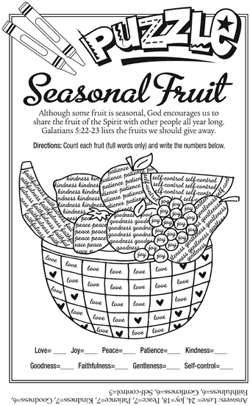
Bible Quiz:
During Israel’s 40-year sojourn in the desert, where did the Lord turn bitter water sweet so the people could drink it?
A. Egypt
B. Mt. Sinai
C. Canaan
D. Marah
Answer: (See Exodus 15:23-25.)
SUNDAY | MONDAY | TUESDAY | WEDNESDAY | THURSDAY | FRIDAY | SATURDAY
“Worry does not empty tomorrow of its sorrow; it empties today of its strength.”  —Corrie ten Boom | 1 | 2  7 PM Music Committee | 3  NO Manor Service  7 PM Bible Study | 4 | 5 | 6
7 Communion Sunday  9:30 AM Sunday School  10:30 AM Morning Worship | 8 | 9  6:30 PM Trustees  7 PM Deacons  7 PM Missions Com | 10  7 PM Bible Study | 11  7 PM ABOUTFACE  7:30 – 8:30 PM  Praise Band | 12 | 13
14  9:30 AM Sun. School  10:30 AM Morning Worship | 15  Lamplighter Articles Due | 16  7 PM C.E. Board | 17  7 PM Bible Study | 18  7:30 – 8:30 PM  Praise Band | 19 | 20
21  9:30 AM Sunday School  10:30 AM Morning Worship | 22 | 23 | 24  7 PM Bible Study | 25  6:30 PM- White  Cross  7:30 – 8:30 PM  Praise Band | 26 | 27
28  9:30 AM Sunday School  10:30 AM Morning Worship | 29 | 30 | 31  7 PM Bible Study | 7:30 – 8:30 PM  Praise Band |  | “Little faith will bring your soul to heaven, but great faith will bring heaven to your soul.”  —Charles Spurgeon
2013 Church Meetings, Activities & Events

