The Lamplighter
DECEMBER 2014
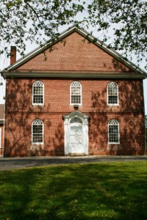
Cohansey Baptist Church

714 Roadstown Road
Bridgeton, NJ 08302
856 – 455 - 7787

Greetings in the name of our Lord and Savior Jesus Christ and I trust that this message finds you well and in good spirits. November was a great month here at Cohansey Baptist Church, as we continued to experience the love, peace, and grace of God in a new and profound way.
Also, let me take the time to express how honored I am to be able to serve as your Pastor. The relationship between pastor and people is sacred, holy, and special and I could not ask for a better people to engage in ministry with. Additionally, I want to remind you, that all of the work, sacrifice, and service that you provide for the Cohansey Baptist Church as we witness to the world for Christ, are greatly appreciated. We are reminded of the words of Jesus, “...the greatest among you will be your servant.” Matthew 23:11
December is one of my favorite months in the calendar year for a number of reasons, most notably the celebration of the birth of our Lord and Savior Jesus Christ. The words of the prophet Isaiah ring as true and moving today as they were when he first wrote them, “...for unto us a Child is born, Unto us a Son is given; And the government will be upon His shoulder. And His name will be called Wonderful, Counselor, Mighty God, Everlasting Father, Prince of Peace.” What a wonderful reality that Jesus Christ has been born and that He was the fulfillment of a promise set forth by God the Father.
In the midst of buying gifts, cooking food, planning parties and the like; I encourage you to remember the true meaning of Christmas and the genuine joy that Christ can bring. In the words of Charles H. Spurgeon who observed so long ago, “...the greatest and most momentous fact which the history of the world records is the fact of Christ’s birth.” There has not been anything that has happened throughout the course of human history more important than the birth of Christ!
I trust that this message blesses you and encourages you in your daily walk with Christ. If I can ever be of service to you, please do not hesitate to contact the office and I look forward to seeing you in church soon!
Your Brother in Christ,
Reverend Alexander G. Houston
Pastor

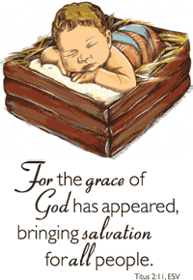

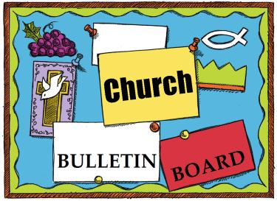
Remember the next newsletter articles, announcements; pictures, etc. are due, December 15, 2014. You can put them in the Newsletter mailbox, email them to me or call me. My email address is: nohowmom@comcast.net and my phone number is 856-455–2574. Thank you!
Thank you to all of those who faithfully give of their time and assemble the newsletter each month.

When filling out your Christmas cards this year, take a card and send to a soldier at this address:

A Recovering American Solider
c/o Walter Reed Army Medical Center
6900 Georgia Avenue
NW Washington, DC 20307-5001
Pass this on and think of how many cards these wonderful special people who have sacrificed so much would get.

Cohansey Baptist will be hosting November 30th thru the December 6th., for the Cumberland County homeless. They are just getting started and they don’t plan on many families. Pray for Aja Redmond as helps families get back on their feet.

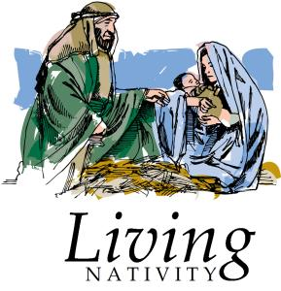

This Saturday, December 6, 2014 6-9PM is our first annual
DRIVE THRU LIVE NATIVITY at Cohansey Baptist Church

Drive through Cohansey’s Live Nativity and witness the true meaning of Christmas. See the story of Christ’s birth while in the comfort and warmth of your own car. Hear the angels singing, see the shepherd’s tending their flock and the Wiseman’s’ journey. Watch King Herod send out his proclamation and see the King of Kings lying in his manager.
Donations of non-perishable food items will be accepted all donations (food or monetary) will be donated to
Code Blue and the Emmanuel Cancer Foundation.

Church Activities and Events (continued)

Children’s Christmas
Musical
“Fact or Fiction”
Christmas musical will be on
Sunday December 7th at 6 PM

We would like to thank you for your generous donations!
We collected a total of 124 shoeboxes for Operation Christmas Child. We also collected $463 plus food and clothing donations for the Atlantic City Rescue Mission.
Sr. BYF & Julie Fleetwood

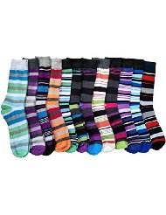
The Missions Board is collecting new socks. They will go to multiple groups, depending on the need: Code Blue, Baptist Children’s Services,

First Crow Baptist Church in Montana and the Atlantic City Rescue Missions. Most needed are new men’s socks but we will accept any new socks. You can place them in the container by the organ.
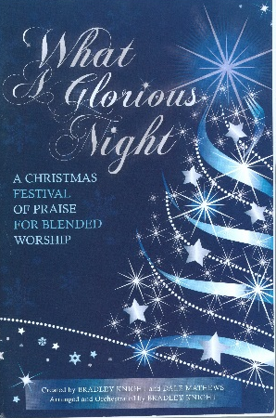
The choir will be presenting “What a Glorious Night” a Christmas festival of praise created by Bradley Knight and Dale Matthews. Join us for a time of rejoicing as we celebrate the birth of our Lord and Savior, Jesus Christ. Saturday, December 20th at 7 PM and Sunday, December 21st at 10:30 AM

White Cross monetary donations are still needed to contribute to health care needs in the Democratic Republic of Congo. Your support will help our partners in the Baptist Community of Congo (C.B.CO) assist a network of hospitals and health centers to provide good medical care for patients otherwise unable to afford treatment . This support will also help provide training to nurses and doctors, and distribution of much needed medications and hospital supplies. We are seeking to raise $250 for this White Cross project.

1 Linda Dickinson
Katelynn Cornell

6 R.C. Holt
Steve Levick
7 Ken Perry
ApriI Sloan
8 Dorothy Turner
9 Kelsey Bayzick

12 Joshua LaTourette
13 Mary Hemple
14 Kim Patchell
16 Matthew Hill
17 Thomas Sloan
Donald Sloan, Jr
Stefani Tobin Hewitt
19 Mary Stretch
20 William Lister

- Jesus Christ
Dan Evans

26 Diane Crispin

28 Robert Mayhew

29 Carol Shimp
Connor Bonham

30 Emily S. Ayars
Stacy Ichinaga

****If your name is not on our Birthday List or there needs to be a correction or your name has changed please let me know by calling 856-455-2574 or by email at nohowmom@comcast.net. Thank you****

Special Dates

Second Sunday of Advent, December 7, 2014
• Third Sunday of Advent, December 14, 2014
• Fourth Sunday of Advent, December 21, 2014
• First Day of Winter, December 21, 2014
• Christmas Eve, December 24, 2014
• Christmas Day, December 25, 2014
• New Year’s Eve/Watch Night, December 31, 2014

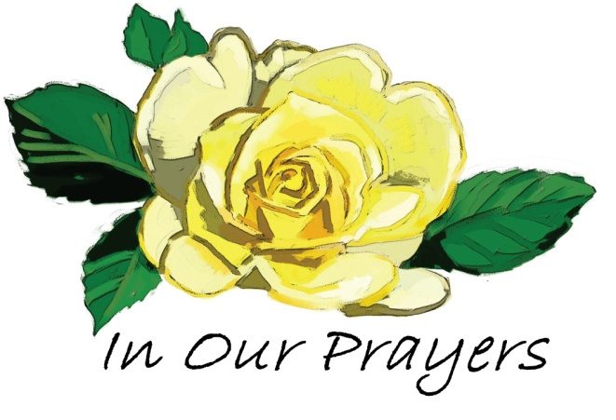

Please keep these people in prayer That God may manifest His healing in them and He will be praised.

Irene Vetro R.C. Holt Lenora Renne Rose Gaggini George Moore Leon Fithian Timothy Ross Carol Shimp Mary Stretch Evelyn Armstrong Princeton Dozier Bob Turner Mary Houston Dot Turner Erica Houston Logan Willis
Prayers of Praise for Jim Soone’s dedication to the Lord.
Prayers for Holli Olbrich Carter who delivered her son Justin prematurely on October 6th weighing 1lb. 8 oz.. Please pray for Justin and his family that he continues to grow and improve. You can follow Justin’s progress on www.caringbridge.org/visit/justincarter.
Please pray for the well-being of our country and our leaders. May God grant them wisdom as they deal with the situations around the world and here at home.
Shut-Ins: Janet Bonaldo Ashley Guntow Ruth Levick Doris Newkirk
Nursing Homes: Anna Dickerson Margaret McAllister
Battling Cancer: Gloria Branca Lisa Haffner Emily Horton Debbie Marks Lake Jeff Mortimer Marion Nickopolous Louise Orsini Ed Peterson Ron Rouver Mike Scavelli Brenda Snyder Aaron Silver, Jr.
Serious Condition: Dave Borrelli
In the Service: Mike Dunkelberger Kyle Mihalecz Nicky Mihalecz Brian Schrier Doug Shimp Russell Shinn Shauna Sloan Andrew Tobin Lance Shestakoff Jay Perticari
College Students: Tyler Davenport Amaryllis DeJesus Katelin Elwell Steve Frantz David Johnson Mindy Williams Samuel Tobin Megan West Melissa Smith Megan Smith

Bethlehem’s Church of the Nativity, which marks the likely spot of Jesus’ birth, has a four-foot-high entrance. Throughout the centuries, the height of the entrance has been lowered twice: once to prevent looting and once to keep out camel- and horse-riders.
Because visitors must bow as they enter, this has become known as the Door of Humility. It’s a reminder of the reverent, submissive posture our hearts should take as we approach our newborn Lord and Savior. It’s also a reminder that Jesus is the narrow door (Luke 13:24) — the only path to eternal life.
As you worship this Christmas season, whether or not you’re physically able to kneel, enter Jesus’ presence with a humble and thankful heart. He alone deserves our reverence because he alone is able to save.

Recipe of the Month:
Cranberry Butter
adapted from Tasty Kitchen
makes about 6 half pints of butter
1 pound of butter (four sticks) softened
1 cup of fresh cranberries
1/3 cup honey (add more if you want a sweeter butter)
zest of one orange
Combine all of these ingredients in a food processor. (Alternatively, you can chop up the cranberries by hand and mix it by hand in a bowl. I have a food processor, and I ain't afraid to use it, so that's what I did.)

Process until smooth, scraping down sides as needed.

Fill jars and enjoy!

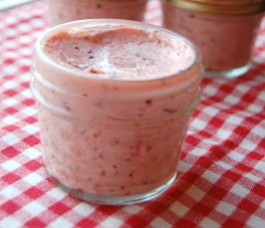

A Special Baby

Mark Lowry, who wrote the lyrics to the Christmas song “Mary, Did You Know?” says he’s always been amazed by Mary’s silence at the cross, as her son was being crucified. Maybe she was remembering back to that first Christmas, he wonders, when she counted Jesus’ fingers and toes.
“I wonder if she realized then that those were the same fingers that had scooped out the oceans and formed the seas. I wonder if she realized those were the same feet that had walked on streets of gold and been worshiped by angels. Those little lips were the same lips that had spoken the world into existence. When Mary kissed her little baby, she wasn’t just kissing another baby; she was kissing the face of God.”
Mary silently watched her son die 33 years later, Lowry notes — not just for the world but also for his own mother. “The baby boy she had delivered on that first Christmas was now on a cross delivering her.”

Upside Down?

Even amid increased secularization, God makes the core Christmas message known. Take, for example, the story of a “winter pageant” a mother attended at her son’s grade school. Songs of reindeer, snow and Santa included one titled “Christmas Love,” in which the youngest performers held up letters as the song progressed: “C,” “H,” etc.
When a little girl unknowingly held her “M” upside down, the older kids snickered and the adult audience smiled acceptingly. But as the song drew to a close and all the letters were revealed, surprised recognition struck the Christians in the room.
“CHRISTWAS LOVE,” read the string of student-borne letters. God’s truth had penetrated the human clutter and confusion around Christmas — as it has power to do throughout our lives: “Christ was love.” And of course, he still is.

Memory Verse:
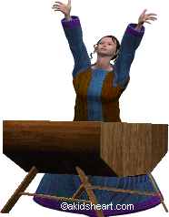
Behold, a virgin shall be with child, and shall bring forth a son,

and they shall call His
name Immanuel, which being interpreted is,
God with us.
~Matthew 1:23

Jokes:
What’s white and goes up?
A confused snowflake!
What do you call an old snowman?
Water!
What do you sing at a snowman’s birthday party?
Freeze a jolly good fellow!
Puzzle:
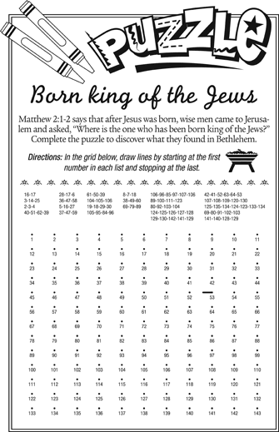
Bible quiz:
What’s the name of the angel who told Mary she would give birth to God’s Son?
A. Gabriel
B. Raphael
C. Michael
D. Jonathan
Answer: (See Luke 1:26ff.)

SUNDAY | MONDAY | TUESDAY | WEDNESDAY | THURSDAY | FRIDAY | SATURDAY
“Jesus did not come to make God’s love possible, but to make God’s love visible.”  —Author unknown | 1  Family Promise Week  7 PM Choir  7:30 PM Cantata | 2  9 AM Prayer Group  7 PM Music Comm. | 3  10:30 AM Manor Service  7 PM Bible Study | 4  7 PM Praise Band | 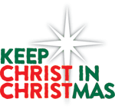  5 | 6  9:45 AM Kids program at Shiloh  6-9 PM Nativity Drive-Thru
7  Communion Sunday  9:30 AM Adult Sunday School  10:30 AM Worship  6 PM Kids Musical | 8  7 PM Choir rehearsal  For Cantata | 9  9 AM Prayer Group  6:30 PM Trustees  7 PM Deacons  7 PM Missions Brd | 10  10:30 AM Manor Service  7 PM Bible Study | 11  7 PM Praise Band | 12 | 13  1 PM Cantata Pract
14  9:30 AM Adult Sunday School  10:30 AM Worship  6-7:45 PM BYF | 15  7 PM Choir rehearsal  For Cantata | 16  9 AM Prayer Group | 17  7 PM Bible Study | 18  7 PM Praise Band | 19 | 20  10 AM Cantata Pract  7 PM Cantata
21  9:30 AM Adult Sunday School  10:30 AM Morning Worship - Cantata  4 PM Caroling BYF and Church Wide | 22  7 PM Choir rehearsal  For Cantata | 23 | 24  6 PM Christmas Eve Service | 25 | 26 | 27
28  9:30 AM Adult Sunday School  10:30 AM Morning Worship | 29  7 PM Choir rehearsal | 30  9 AM Prayer Group | 31 | An old Danish Christmas hymn proclaims that “the heavenly guest” comes to us “with new year gifts of peace, good will” (Nicolai F.S. Grundtvig, “The Bells of Christmas,”

