The Lamplighter
DECEMBER 2013
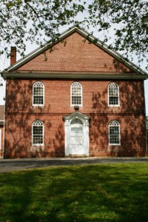
Cohansey Baptist Church

714 Roadstown Road
Bridgeton, NJ 08302
856 – 455 - 7787

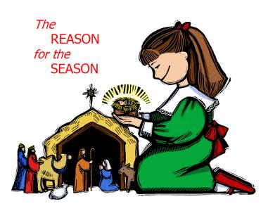
Happy December! I trust that this message finds you well and in great spirits as we move into this last month of 2013. I cannot believe the year has gone by so quickly, but I guess the saying is true, “Time flies when you’re having fun!” November was a great month at Cohansey Baptist Church as we continued serving God together in worship, fellowship, and service. I am so proud of all of the volunteers, members, and leaders who worked together to make Family Promise a reality in Cumberland County, as we hosted homeless families at the church during the week of Thanksgiving 2013. The Scriptures tell us “it is more blessed to give than to receive” because when we give it allows us to be a blessing to someone else. Homelessness is a difficult reality, and I am glad we were able to pitch in and help in their time of need.
As we set our sights on Christmas, we are reminded that God gave us the best gift of all when He sent His Son into the world. It was in the 8th century B.C. that the prophet Isaiah, inspired by the Holy Spirit, wrote these words,“…for to us a child is born, to us a son is given, and the government will be on his shoulders. And he will be called Wonderful, Counselor, Mighty God, Everlasting Father, and Prince of Peace.” Isaiah’s words of hope and redemption resonated throughout history until the moment when Christ was born. With the coming of Christ, we now have the opportunity to fully experience the prophetic words of Isaiah. We have the privilege of embracing a personal relationship with Christ. I am ever grateful that God allowed Christ to come to earth because in Him, we have the ability to live in a place of happiness, joy, and contentment now and forever. Remember that the birth of Christ is and always will be the “reason for the season.”
I trust that this message blesses and encourages you. Enjoy this yuletide season, and I look forward to seeing you in church soon. As always, if I can be of any service to you, please just let me know!

Your Brother in Christ,
Rev. Alexander G. Houston
Pastor

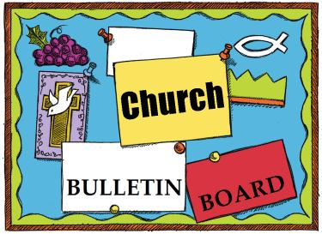

Remember the next newsletter articles, announcements; pictures, etc. are due, December 15, 2013. You can put them in the Newsletter mailbox, email them to me or call me. My email address is: nohowmom@comcast.net and my phone number is 856-455–2574. Thank you!
Thank you to all of those who faithfully give of their time and assemble the newsletter each month.

Sunday, Dec. 8th at 1 p.m. – Sr. BYF Caroling
Saturday, Dec. 14th at 6 p.m. – Progressive Dinner
Saturday, Dec. 21st at 9:45 a.m. – Children’s Christmas Musical at Shiloh 7th Day Baptist.
Saturday, Dec. 21st at 7 p.m. – Christmas Cantata
Sunday, Dec. 22nd at 10:30. – Christmas Cantata
Sunday, Dec. 22nd at 6 p.m. – Children’s Christmas Musical at Cohansey Baptist.
Tuesday, Dec. 24th at 6 p.m. – Christmas Eve Candlelight Service

Let’s go Caroling!
The Sr. B.Y.F would like to invite you to join them as they go Christmas caroling on Sunday Dec. 8th @ 1:00 p.m.
Feel free to pack a bag lunch and go directly to Berean after church, or just meet them at Berean at 1 p.m. For more info, contact Julie Fleetwood.
We would like to thank you for your generous donations!
We collected a total of 149 shoeboxes for Operation Christmas Child. We also collected $400 plus food and clothing donations for the Atlantic City Rescue Mission.

Let’s get together for an adult progressive dinner for an evening of fun, fellowship, and lots of food! We are looking for 1 or 2 more families who are willing to open up their homes on the evening of Saturday, December 14th starting at 6:00 pm.
Each course will be held at a different home, our last stop ending with dessert. Please contact Penny Timberman at 455-4394 if you would like to host one of the courses.
We will have a white elephant gift exchange at our last stop. If you want to participate, each person must bring a wrapped gift between $10 - $15 that is NEW or “like” NEW. The idea is to be very secretive so make sure not to put your name on the gift.
We have such a great time together at this event. Please consider joining us this year!
Please see the sign-up sheet in the narthex. Our hosts will also need help with food so please let us know if you can bring something!

Friendly Reminder!
If you have any altar flower cans please remember to return them to the church. Also, new cans are always appreciated. Thank you!

MISSIONS TRIP IN 2014
The Missions Committee is looking for input from the entire congregation.
Our first brainstorming session will be Tuesday, Dec 10th at 7:00 pm (downstairs Sunday School room area) and will be first on the agenda. Come out - bring a friend - spread the word.
We want to hear YOUR ideas as to Where, What, When, How.
Jesus tells us to "take care of my sheep" [John 21:16].
Since 1935, American Baptists have contributed to special offerings received in their churches for retired ABC ministers and missionaries or their widowed spouses. In 1977, American Baptist Churches USA launched the Retired Ministers and Missionaries Offering (RMMO) to continue this tradition of thanks.
Today, RMMO is a tangible way for the American Baptist congregations to say “Thank you for …” the commitment, service and spiritual guidance of retired ministers, missionaries and their widowed spouses.
This offering supports those who have devoted 15 or more years of their lives to God’s service by providing emergency assistance in times of need and a thank you check at the end of each year.
Envelopes are available in the pews. If you would like more information, contact any Mission Committee member or go to http://www.abc-usa.org/rmmo/.

1 Linda Dickinson
Katelynn Cornell
6 R.C. Holt
Steve Levick
7 Ken Perry
ApriI Sloan
8 Dorothy Turner
9 Kelsey Bayzick
12 Joshua LaTourette
13 Mary Hemple
14 Kim Patchell
16 Matthew Hill
17 Thomas Sloan
Donald Sloan, Jr
Stefani Tobin Hewitt
19 Mary Stretch
20 William Lister
23 Alice Moore
- Jesus Christ
Dan Evans

26 Diane Crispin
28 Robert Mayhew
29 Carol Shimp
Connor Bonham
Harry Lodge
30 Emily S. Ayars
Stacy Ichinaga

****If your name is not on our Birthday List or there needs to be a correction or your name has changed please let me know by calling 856-455-2574 or by email at nohowmom@comcast.net. Thank you****

Special Dates:
• First Sunday of Advent, December 1, 2013
• Second Sunday of Advent, December 8, 2013
• Third Sunday of Advent, December 15, 2013
• First Day of Winter, December 21, 2013
• Fourth Sunday of Advent, December 22, 2013
• Christmas Eve, December 24, 2013
• Christmas Day, December 25, 2013
• New Year’s Eve/Watch Night, December 31, 20

Each Christmas, a family celebrated by holding a birthday party for Jesus. To remind themselves of Jesus’ presence, they placed a chair of honor for him at their dinner table.
The highlight of the party was singing “Happy Birthday” to Jesus and then blowing out the candles on a special cake.
One Christmas, a visitor asked the family’s 5-year-old daughter, “Did you get everything you wanted for Christmas?”
The girl paused and then answered, “No! It’s not my birthday!”

Please keep these people in prayer as they deal with various physical problems. Pray for healing and complete recovery.
Doris Newkirk Don Stanson Irene Vetro Bud Newkirk John Carman Heath Willis Howard Willis, Sr. George Willis Sherry Willis Cindy Hewitt Samantha Ford Lois Hepner Sue Panichello Courtney Etherton Evelyn Armstrong Babe McDermott Sharon Guth Emily Mayhew’s granddaughter, Megan
Please pray for those who have recently lost loved ones:
The Family and friends of Don Dulin
Prayers of Praise for Answers to Prayer:
Vera Mayhew is healing and out and about Deirdre Athey’s new grandson Helen Perry’s new great granddaughter, Erin Lisa Haffner celebrating life after 6 months of her diagnosis.
Please pray for the well-being of our country and our leaders. May God grant them wisdom as they deal with the situations around the world and here at home.
Shut-Ins: Janet Bonaldo Ashley Guntow Arthur Levick Ruth Levick
Retirement Homes: Ed Smith
Nursing Homes: Don Brammer Anna Dickerson Jeanette Merritt Margaret McAllister Alice Moore
Battling Cancer: Jayme Bickings Gloria Branca Cindy Frederick Lisa Haffner Emily Horton Debbie Johnson Giavana Krumaker Tom Laquitara Jonathan Lopez Debbie Marks Lake Jeff Mortimer Marion Nickopolous Jose` Nieto Louise Orsini Ed Peterson Ron Rouver Mike Scavelli Brenda Snyder Paige Whitesell
Serious Condition: Dave Borrelli Jeffrey Garton
In the Service: Mike Dunkelberger Ryan Fithian Andy Guth Kyle Mihalecz Nicky Mihalecz Brian Schrier Doug Shimp Russell Shinn Shauna Sloan Andrew Tobin Lance Shestakoff
College Students: Tyler Davenport Amaryllis DeJesus Ashleigh Elwell Katelin Elwell David Johnson Mindy Williams Samuel Tobin Megan West
The hustle and bustle of the season can feel overwhelming, God. Thank you for this time apart from the world, where I can focus on the true meaning of Christmas. Amen
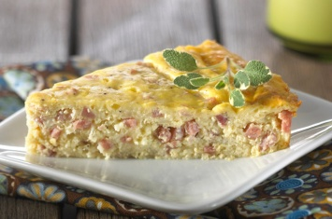
Recipe of the Month:

INGREDIENTS
1/4 cup Keebler® Vanilla Wafers (finely crushed, about 6 cookies), divided
1/4 cup finely chopped onion
1 tablespoon butter or margarine
1 1/4 cups shredded Swiss cheese
1 cup finely chopped ham
1 cup sour cream
2 teaspoons prepared mustard
1/4 teaspoon pepper
4 eggs, slightly beaten

DIRECTIONS
1. Coat 9-inch pie plate with nonstick coating. Sprinkle 1 tablespoon of cookie crumbs in pie plate. Set aside.
2. In small saucepan cook onion in butter until tender. In medium bowl stir together remaining 3 tablespoons cookie crumbs, onion mixture, cheese, ham, sour cream, mustard and pepper. Stir in eggs. 3. Pour into prepared pie plate. Bake at 325°F about 35 minutes or until knife inserted near center comes out clean. Let stand for 10 minutes. Cut into wedges. - See more at: http://www.snackpicks.com
Lessons from the angels
To frightened shepherds on the first Christmas Eve, a host of angels sang, “Glory to God in the highest, and on earth peace, good will toward men” (Luke 2:14, KJV).
Nineteenth-century minister Charles Kingsley explained how these key words tell the meaning of Jesus’ birth and give meaning to our lives.
• Glory. “That little babe, lying in the manger among the cattle, was showing the very highest glory of the great God who had made heaven and earth. To stoop, to condescend, to have mercy, to forgive — that is the highest glory of God.”
• Peace. “God is not selfish. He sacrificed himself for us. Sacrifice yourselves then for each other! Give up your own pride, your own selfishness, your own interest for each other, and you will be all at peace.”
• Good will. “God loves you, and he wills to raise you out of this selfish, quarrelsome life of sin, into a loving, brotherly, peaceful life of righteousness. That babe in the manger at Bethlehem is a sign to you and me that God will freely give us that spirit of love if we ask for it.”

Howard and I have much to thank God for this year. We would like to take this opportunity to not only thank Him, but also thank our church family. Your cards, calls , visits, fruit baskets, flowers and kind thoughts have truly been appreciated during the last six months. What has meant the most are the prayers that you have been sending up. We have seen and felt God working and felt your prayers. Howard still has to get through six weeks of Chemo and radiation which will begin on December 4th. We ask for your continued prayers during this time. Our prayers is that God richly bless all of you today and always.
With deep appreciation, Nola and Howard Willis

Memory Verse:
Behold, a virgin shall be with child, and
shall bring forth a son, and they shall call His
name Immanuel, which being interpreted is,
God with us.
~Matthew 1:23
Jokes:
What’s white and goes up?
A confused snowflake!
What do you call an old snowman?
Water!
What do you sing at a snowman’s birthday party?
Freeze a jolly good fellow!
Puzzle”
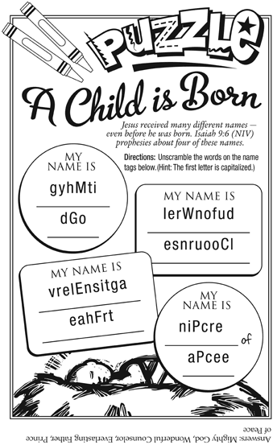

Bible quiz:
According to Scripture, what does the name Jesus mean?
A. “God is with us.”
B. “Anointed One of God”
C. “[The Lord] will save his people from their sins.”
D. “Son of the Most High God”
Answer: (See Matthew 1:21.)

IM missionaries serving in the Philippines, Debbie Mulneix and Jonathan and Thelma Nambu, report that relief efforts are beginning to take effect in the typhoon-stricken areas in this Southeast Asian country. Located in and near Manila, the missionaries are safe as this part of the Philippines was mildly affected.

The storm hit on November 8, 2013 and it is estimated that more than 3,600 people lost their lives, according to the BBC. The number of injured stands at over 12,400.

In a Baptist World Aid news release on November 14, Judson Herbilla, general secretary of the Convention of Philippine Baptist Churches (CPBC), said communication was difficult as phone lines were down and travel by road, ferry or air to the affected areas was not possible. The CPBC is an American Baptist International Ministries (IM) partner.

Herbilla estimated that there were 2,000 families in immediate need of help. He said many churches were affected by the typhoon. Among the urgent needs are for food, water, medicine and construction materials for housing.

According to Mulneix on Friday, November 15, many of the schools and organizations around the country were volunteering to donate food, and were going to pack it for distribution.

Three days after the storm hit, $10,000 in emergency relief funds was sent from One Great Hour of Sharing to help victims of this massive typhoon. IM’s partners around the world are pitching in to help. The Rev. Carlos Sanchez, pastor of the First Baptist Church of San Salvador, El Salvador, one of IM’s partner churches, raised $605 in a special offering, reported Jose Norat, IM area director for Iberoamerica and the Caribbean. “This is a church of modest means,” stated Norat. “This means a lot.”
“Earlier this week, IM partners, CPBC and Philippine Baptist Church Development Ministries, in coordination with the Asia Pacific Baptist Aid of Asia Pacific Baptist Federation, received requests for relief in the hardest hit areas in the provinces of Capiz, Iloilo and North Negros where the majority of CPBC churches are situated,” reported Dr. Benjamin Chan, IM area director for East Asia, India, Hong Kong and China. “CPBC would like to assist in the immediate needs of families by providing food, drinking water, blankets and mats. CPBC is coordinating with government officials to be able to reach the affected areas."
U.S. and Puerto Rico churches are asked to keep the victims, their families, their churches and the Filipino churches in the U.S. in prayer.

SUNDAY | MONDAY | TUESDAY | WEDNESDAY | THURSDAY | FRIDAY | SATURDAY
1  Communion Sunday  9:30 AM Sunday School  4:30-5:30 Kid’s Musical Rehearsal - Cohansey  10:30 AM - worship  6 – 7:30 PM – BYF | 2  7 PM Choir Cantata Rehearsal | 3  9 AM Prayer Group  7 PM Music Comm. | 4  10:30 AM Manor Service  7 PM Bible Study | 5  7:30 – 8:30 PM  Praise Band Rehearsal | 6 | 7
8  9:30 AM Sunday School  10:30 AM Morning  Worship  4:30-5:30 PM BYF Caroling  4:30-5:30 PM Kid’s Musical Rehearsal  NO BYF | 9  7 PM Choir Cantata Rehearsal | 10  9 AM Prayer Group  6:30 PM Trustees  7 PM Deacons  7 PM Missions | 11  7 PM Bible Study | 12  7:30 – 8:30 PM  Praise Band Rehearsal | 13 | 14  10 AM Cantata Rehearsal  6 PM Adult Progressive Dinner
15  9:30 AM Sunday School  10:30 AM Worship  4:30–5:30 Kid’s Musical Rehearsal - Cohansey  6 – 7:30 PM BYF | 16  7 PM Choir Cantata Rehearsal | 17  9 AM Prayer Group  7 PM C.E. Board | 18  7 PM Bible Study | 19  6:30 PM White Cross Work  7:30 – 8:30 PM  Praise Band Rehearsal | 20 | 21  9:45 AM Children’s Musical @ Shiloh  1 PM Cantata Rehearsal  7 PM Cantata
22  9:30 AM Sunday School  10:30 AM Morning Worship - Cantata  6 PM Children’s Christmas Musical | 23  7 PM Choir Cantata Rehearsal | 24  6 PM Christmas Eve Candlelight Service | 25 | 26 | 27 | 28
29  9:30 AM Sunday School  10:30 AM Morning Worship  6 – 7:30 BYF | 30  7 PM Choir | 31  New Year’s Eve!
DECEMBER 2013 Church Meetings, Activities & Events

Acts 20:35 New International Version
Isaiah 9:6 New International Version

