The Lamplighter
SEPTEMBER 2014
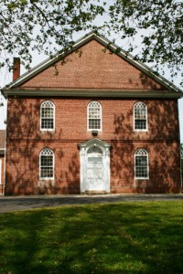
Cohansey Baptist Church

714 Roadstown Road
Bridgeton, NJ 08302
856 – 455 - 7787

Greetings to you in the name of our Lord and Savior Jesus Christ. I trust that this message finds you well and in great spirits. It has been a wonderful summer here at Cohansey Baptist Church as we have continued serving the Lord with joy and gladness. Our summer sermon series, Psalms for the Summer, was a blessing to our congregation. So many people offered suggestions for sermons, words of encouragement, and words of thanks for the sermons shared. More importantly, it was fun to explore the Psalms each week! As we look toward the fall, I am encouraged by the breadth of ministry that is taking place in our midst and I pray that you are excited as well. Although the pace of the church calendar and our individual lives will pick up with the transition from summer to autumn, I hope that you will find time to enjoy the “small” things in life.

I was just commenting the other day to someone about how fast life seems to be going. As you can probably relate, some days are so fast and filled that I can’t get a moment to breathe and decompress. However, as we were talking, I remembered a quote that I had read recently, “...enjoy the little things in life...for one day you’ll look back and realize they were the big things.” As I have had time to reflect on the power of this message, I realize with new clarity that I must give time to all of the “little” things around me and not fall victim to the condition of being, “busy.” Sometimes we find ourselves in spaces of being “busy” that we fail to pray, or to study God’s word, or to reach out to one of brothers/sisters in Christ who could really use a word of encouragement. We get so “busy” that we can’t seem to make time for church, for our families, or for our friends. Brothers and sisters I encourage you to take time to enjoy the “small” things of life: the change of seasons, the dawn of a new day, breakfast with the one you love, the changing of baby’s diapers, the conversations had with an older adult. As we focus on the seemingly “small” things of life, we will recognize that they are the things which continue to fill us up so that we can be more useful to God. Additionally, as we seek out the “little” things in life, we will have the opportunity to not fall victim to the truth that the Apostle Paul spoke, “...for although they knew God, they neither glorified him as God nor gave thanks to him...” (Romans 1:21) Let us praise God at all times, in our joys and struggles, in our “busyness” and especially in the “small” things. In all things, no matter how great or small, remember that God is with you and that He loves you.

I trust that this message blesses and encourages you. If I can be of any service, please do not hesitate to contact the church office and I look forward to seeing you in church soon.

Peace and Blessings,

Rev. Alexander G. Houston
Pastor

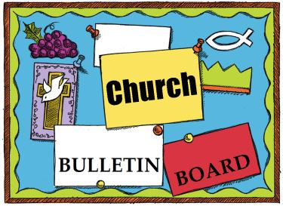
Remember the next newsletter articles, announcements; pictures, etc. are due, September 15, 2014. You can put them in the Newsletter mailbox, email them to me or call me. My email address is: nohowmom@comcast.net and my phone number is 856-455–2574. Thank you!
Thank you to all of those who faithfully give of their time and assemble the newsletter each month.

325th Anniversary
In 2015 our church will be celebrating its 325th year of service to the Lord. We need to start planning for this event, if you would like to be a part of the planning process, please see Penny Timberman.
Fund Raiser “Quarterly Funds”
Family Promise of Cumberland County is asking the congregations to help us out, in the opening up and in the operation of their Family Center. We are distributing quarter money wrappers for you to fill, each one holds $10.00. When they are filled you can place them in the offering plate. This is a way everyone can help keep families together and help them get back on their feet. Thank you!

Carlos Bonilla and Mayra Giovanetti will be at
Cohansey Baptist Church
714 Roadstown Rd.
Bridgeton, NJ 08302
September 19, 2014 from 6:00PM to 8:30 PM
Please join us for dinner and
support the Bonilla-Giovanetti family.

Carlos Bonilla and Mayra Giovanetti have been long-term commissioned missionaries serving through the American Baptist Foreign Mission Society (a.k.a. American Baptist International Ministries) since 2000 (Chile 2000-2009, Spain 2010-2012, Nicaragua (2013-present). Carlos and Mayra are American Baptist ordained ministers. They are currently serving through the Baptist Theological Seminary, a ministry of the Baptist Convention of Nicaragua, and their satellite centers in the rural communities of this land of lakes, volcanoes, poets, and contrasts. Educational materials will be displayed to remember the work of Adoniram and Ann Judson. A free-will offering will be taken to assist the family on their journey.
If you want to help plan this event contact, Dee Johnson at crafdee@gmail.com or 856-455-6462

3rd – Carroll Bickley
Bernard DeVol
David Seay
4th – Anthony Maltese
Bradley Silver
5th - Alan Gregory
Billy Halter
Ken Hill
7th - Irving Gandy, III
Logan Willis
10th – Patti Lister
11th - Irving Gandy, IV
12th- Emily Grindle
14th – Natasha Wagner
16th – Dale Cruzan, III
Lindsay Fithian
Kim Austin

19th – Charlotte Higgenbothem
Margaret Kates
Howard Willis, Jr.
20th – Ella Marino
21st - Jessica Shimp
22nd- Garry Timberman
25th - Terri Hitchner
Melissa Smith
28th - Bucky Tharp
29th - Joyce Wagner
Ellen Davis
30th - Sallie Counselor

****If your name is not on our Birthday List or there needs to be a correction or your name has changed please let me know by calling 856-455-2574 or by email at nohowmom@comcast.net. Thank you****

Special dates

• Labor Day, September 1, 2014
• National Grandparents Day, September 7, 2014
• Patriot Day, September 11, 2014
• Hispanic Heritage Month, September 15–October 15, 2014
• First Day of Autumn, September 23, 2014

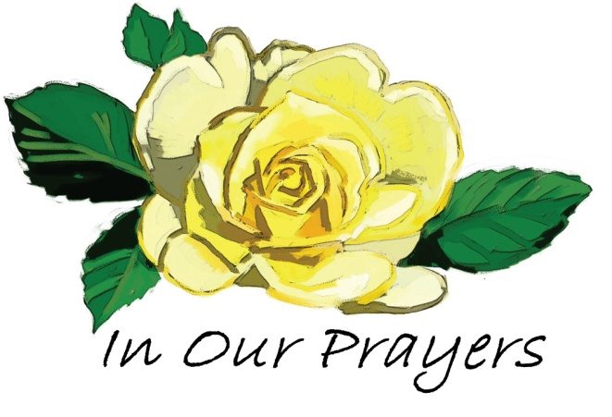

Please keep these people in prayer as they deal with various physical problems. Pray for healing and complete recovery.
Irene Vetro R.C. Holt Evelyn Armstrong Bill Felmey Rose Gaggini George Moore Polly Davenport Nola Willis Sharon Guth Timothy Ross Dot Lewis Helen Rammel
Please pray for the well-being of our country and our leaders. May God grant them wisdom as they deal with the situations around the world and here at home.
Shut-Ins: Janet Bonaldo Ashley Guntow Arthur Levick Ruth Levick Doris Newkirk
Nursing Homes: Anna Dickerson Margaret McAllister
Battling Cancer: Gloria Branca Lisa Haffner Emily Horton Debbie Johnson Giavana Krumaker Jonathan Lopez Debbie Marks Lake Jeff Mortimer Marion Nickopolous Jose` Nieto Louise Orsini Ed Peterson Ron Rouver Mike Scavelli Brenda Snyder Paige Whitesell
Serious Condition: Dave Borrelli
In the Service: Mike Dunkelberger Ryan Fithian Kyle Mihalecz Nicky Mihalecz Brian Schrier Doug Shimp Russell Shinn Shauna Sloan Andrew Tobin Lance Shestakoff
College Students: Tyler Davenport Amaryllis DeJesus Katelin Elwell Steve Frantz David Johnson Mindy Williams Samuel Tobin Megan West Melissa Smith Megan Smith
I want to thank everyone for your prayers for my sister, Marion English. She is now in the Lord’s hands (Heaven). Also thank you for your prayers for my brother, David Sickler, who has joined our sister Marion in heaven. You are all so kind.
Mary Hemple

There's an app for that!
These days, there’s a smartphone app for just about everything. But what about spiritual concerns? Where can you turn?
• Depressed? Try the joy app. Read Isaiah 51:11.
• Tired? Try the renewal app. Read Isaiah 40:30-31.
• Unsettled? Try the peace app. Read Philippians 4:7.
• Unloved? Try the love app. Read Romans 8:38-39.
• Worried? Try the refuge app. Read Psalm 46:1.
• Fearful? Try the power app. Read 2 Timothy 1:7.
• Guilty? Try the forgiveness app. Read Colossians 1:13-14.
• Praying? Try the prayer app. Read 1 John 5:14-15.
The Scriptures are God’s storehouse of meaningful applications for what we face every day. Think of the Bible as the iTunes Store of spiritual apps. Best of all, everything’s free!
—Timothy Merrill

Recipe of the Month:

Make your kids’ lunchbox just a little more fun with this easy sushi sandwich. Grab a pack of Whole Grain Flour Tortillas. Add a few slices of your child’s favorite lunch meat and then a cheese stick in their favorite flavor. Carefully roll this up and then slice in half with a sharp knife. Add a juice box and some fresh seasonal fruit, veggie sticks and pretzels for a healthy fun lunch.

The Joy of Teaching
What an awesome job I’ve got,
to nurture these dear precious tots
and help them know their lives were bought
when Jesus gave his blood and sought
to save the soul of every tot.
What an awesome job I’ve got,
to share the gospel with these tots
and plant in them with every thought
the prize of heaven Jesus brought
to save the soul of every tot.
What an awesome job I’ve got,
to teach against the devil’s plot
and amplify what Jesus taught
and glorify what God has wrought
to save the soul of every tot!
—MaryAnn Sundby

Creation's Splendor
In Romans 1:20, St. Paul writes that God’s powers are on display for all people through creation. Humans, he reasons, should conclude there’s a God simply by observing.
What does creation’s splendor and beauty reveal to us about God? Take a moment and stick your head out the window. It’s amazing how colorful creation is. God isn’t a boring God who sees only in black and white. He’s a God of beauty with an amazing imagination. God creates with a splash of joy.
Every day this week, stop and ask, “What is God’s creation revealing to me about his character?”
—Rev. Mike Paulson

Memory Verse:

Pray without ceasing.
~I Thessalonians 5:17

Jokes:
Q. Why do cats always go after mice and birds?
A. Because cats like fast food.
Q. What makes seven even?
A. Taking the S away!
Q. Where do bees go after they are married?
A. On their HONEY-moon!

Puzzle:

Bible quiz:
According to Luke, how many disciples did Jesus send out two by two ahead of him to the various towns he planned to visit?
A. 12
B. 70 or 72 (ancient manuscripts vary)
C. 490 (70 times 7)
D. 144 (12 times 12)
Answer: (See Luke 10:1.).

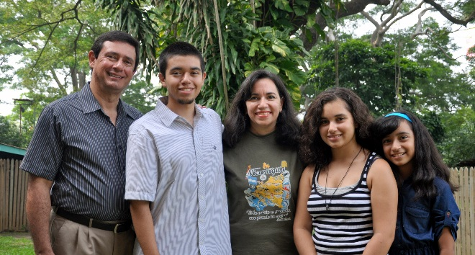
SAVE THE DATE: SEPTEMBER 19

We will have an evening of fellowship and food when "The BG's" visit Cohansey Baptist on September 19th from 6:00 pm until 8:30 pm. After a covered dish supper we will hear all about the Nicaraguan ministry of the Bonilla/Giovanetti family.

Bring your family and friends! A sign up sheet for dinner items is in the narthex. A free will offering will be taken for the BG family.

The BG's were able to attend the World Mission Conference recently held in Green Lake, Wisconsin. Two hundred years of Baptist missions were celebrated by missionaries serving around the world. Carlos, Mayra and their children are spending 16 weeks traveling to 16 states of the USA - visiting the many churches that provide support for them. They will be dropping Alberto off at Eastern University prior to their visit with us; returning to Nicaragua on October 2nd. Your prayers are appreciated for the logistics and safety as they travel.

We are having this event to honor the 200th anniversary of a couple of young adults in their 20's, Adoniram and Ann Judson, who had the courage to follow their beliefs and had the entrepreneurship to start the mother of all Baptist mission societies in America. They had the courage to go to a very different place and stay there, producing a Christian witness that has been passed down to our time.

“Teach us to number each of our days so that we may grow in wisdom.”
Psalm 90:12

Carlos Bonilla and Mayra Giovanetti are working with the Baptist Theological Seminary in Nicaragua, accompanying them in the program of informal theological education in the churches of the Baptist Convention of Nicaragua and as writers of curriculum material for the Seminary. They have been long-term missionaries serving through our mission society since 2000. They and their children live in the land of lakes, volcanoes, poets, and contrasts.

Nicaragua is situated in Central America. It is politically divided in 15 departments and 2 special regions. It has a population of 5.5 million people. The capital city is Managua, which has a higher population density. The Baptist Convention of Nicaragua is present in all departments with its 240 churches organized in 9 regions, 4 organizations, and 5 institutions and programs.

Carlos and Mayra communicate with their churches and partners through their updates, Acts in Action--BGsEnRoute, available regularly. They seek each day to show others God’s love and mercy, as a reality. They consider it a wonderful privilege to be able to serve God and to practice what the Lord placed in their hearts: "Rejoice with those who rejoice, and weep with those who weep.” Romans 12:15

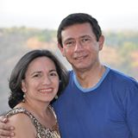
Learn more about the BG's and other American Baptist missionaries at: http://www.internationalministries.org/teams/50-bonilla-giovanetti Follow the BG's on FaceBook: https://www.facebook.com/BGsEnRoute

Empowering your gifts to transform the world.
Dear Cohansey Baptist Church Members and friends,
Almost 2,000 years ago, the Apostle Paul saw a vision of a man saying, “Come over to Macedonia and help us.”
Today, that same call is being echoed all over the world—from Myanmar and Brazil to South Africa and Macau. People are crying out for the hope and light of the gospel in a world darkened by sin.
At CBC we’re committed to Jesus’ Great Commission to “make disciples of all the nations….” (Matthew 28:19) One of the practical ways we can do this is by supporting our annual World Mission Offering.
During worship from August 31, 2014 through October 5, 2014 we’ll learn about the World Mission Offering using the theme Rise to the Challenge and the Macedonian Vision found in Acts 16.
Together, we’ll have our hearts touched by the spiritual needs around the world. Together, we’ll see how International Ministries is working to place and sustain missionaries around the world. Together, we’ll be inspired to apply the biblical principles of Acts 16 to our daily lives.
And Together, we’ll celebrate how our World Mission Offering gifts make possible the ministries of 114 long-term IM missionaries and more than 1,800 short-term missionaries and volunteers working with more than 200 partner organizations in more than 70 countries.
I believe that when we Rise to the Challenge, God will lead us to provide increased support for worldwide mission. Our 2014 World Mission Offering goal is $1500. Please join together as we gain a deeper understanding of International Ministries and of how others (and we ourselves!) will be blessed through our World Mission Offering giving.
Your Servants for Christ,
The Mission Board

THE SLURRY WALLS OF LIFE: As horrific as 9/11 was, it could’ve been even worse if not for a 30-year-old engineering feat. Reaching some 70 feet underground, a 3-foot-thick concrete structure called a “slurry wall” surrounded the base of the World Trade Center complex. Designed to prevent the Hudson River from flooding the basement, this wall prevented New York’s subway system from flooding and countless additional people from dying on September 11, 2001. A slurry wall is constructed by pouring a thick, goopy mixture of powdered clay and water into a deep, narrow trench. The solution coats the sides, preventing water and soil from collapsing the trench. Pipes are then inserted through the slurry, and concrete is pumped into the trench, pushing the slurry up and out. At the WTC, the concrete formed such a strong wall that even two airplanes and the falling towers didn’t fracture it. Part of the slurry wall still stands at the 9/11 Memorial site, a symbol of resilience. Sometimes God uses life’s “slurry” to make us stronger than we ever thought possible. We might wish something yucky hadn’t happened — until we discover it was part of what sustained us, making us resilient and enabling us to rise out of destruction and death to awe-inspiring new life. From NewsletterNewsletter

SUNDAY | MONDAY | TUESDAY | WEDNESDAY | THURSDAY | FRIDAY | SATURDAY
A busy new school and church year is upon us. Bless all who teach and learn, Lord, today and every day. | 1 | 2 | 3  10:30 AM Manor Service  7:00 PM Bible Study | 4  7 PM Praise Band | 5 | 6
7  Communion Sunday  9:30 AM Adult Sunday School  10:30 AM Worship & Children’s Sunday School | 8  7 PM Choir rehearsal | 9  9 AM Prayer Group  6:30 PM Trustees  7 PM Deacons  7 PM Missions Brd. | 10  7 PM Bible Study | 11  7 PM Praise Band | 12 | 13
14  9:30 AM Adult Sunday School  10:30 AM Worship & Children’s Sunday School | 15  7 PM Choir rehearsal | 16  9 AM Prayer Group | 17  7 PM Bible Study | 18  7 PM Praise Band | 19  6 PM Dinner with the B G’s (Carlos Bonilla and Mayra Giovanetti) | 20
21  9:30 AM Adult Sunday School  10:30 AM Morning Worship & Children’s Sunday School | 22  7 PM Choir rehearsal | 23  9 AM Prayer Group  7 PM Brd. of Christian Ed.  7 PM Hospitality Mtg.  Autumn Begins | 24  7 PM Bible Study | 25  7 PM Praise Band  7 PM Baptist Believers | 26 | 27
28  9:30 AM Adult Sunday School  10:30 AM Morning Worship & Children’s Sunday School | 29  7 PM Choir rehearsal | 30  9 AM Prayer Group |  |  | “Be a rainbow in someone else’s cloud.”  —Maya Angelou
Church Meetings, Activities & Events

